Financial Inclusion Through AI: A Deep Reinforcement Learning Model for Micro-Capital Female Investors.
By
Oluwateniola Oyinkansola Obiwole
(w20128641)
Supervised by
DR PHILIP WORRALL
Submitted in partial fulfilment of the requirements of
the School of Computer Science & Engineering
of the University of Westminster
for award of the Master of Science
in
Data Science and Analytics
September 2025

DECLARATION
I, OLUWATENIOLA OYINKANSOLA OBIWOLE, declare that I am the sole author of this Project; that all references cited have been consulted; that I have conducted all work of which this is a record, and that the finished work lies within the prescribed word limits.
This has not previously been accepted as part of any other degree submission.
Signed :
Date : | 04/09/2025

FORM OF CONSENT
I, OLUWATENIOLA OYINKANSOLA OBIWOL, hereby consent that this Project, submitted in partial fulfilment of the requirements for the award of the MSc degree, if successful, may be made available in paper or electronic format for inter-library loan or photocopying (subject to the law of copyright), and that the title and abstract may be made available to outside organisations.
Signed :
Date : | 04/09/2025

ABSTRACT
This dissertation investigates the application of deep reinforcement learning (DRL) to address the financial inclusion gap for low-income women. The project deviates from traditional, passive investment strategies, which often do not meet the unique financial needs of this demographic, by focusing on an active, algorithmic trading model designed to generate consistent, short-term profits. A DRL agent was trained with a specialized reward function to prioritize capital preservation and frequent small gains over large, volatile returns. The evaluation demonstrated that the most effective model, trained for 500,000 timesteps, significantly outperformed established baselines, including Buy-and-Hold and Equal-Weighted strategies, in terms of cumulative returns and final portfolio value. However, a critical limitation was identified: a consistent and severe failure to manage liquidity and meet scheduled client withdrawals. This finding reveals a fundamental flaw in the model's training, as the agent prioritized investment over cash management, rendering it unsuitable for the intended real-world application. While the research proves the potential of DRL for creating profitable trading systems, it concludes that the solution is not yet feasible for this specific use case and highlights the need for a significant redesign of the reward function to properly incentivize liquidity management in future work.

ACKNOWLEDGEMENT

I must thank my parents, Mr Oladokun Obiwole and Mrs Folasade Obiwole for their unwavering support, motivation, and encouragement throughout my studies and the process of conducting this research. Their constant inspiration made this achievement possible.
In addition, I would like to express my sincere gratitude to my project supervisor, Dr. Philip Worrall, in the Faculty of Science and Technology at the University of Westminster. His invaluable support, guidance, and responsiveness throughout the development of this project were instrumental to its completion.

Table of Contents
Chapter 1. Introduction 11
1.1 Background and Context 11
1.2 Aim of the Project 12
1.3 Objectives 12
Chapter 2. Related Work and Review of Literature 13
2.1 Related Work 13
2.1.1 Financial Inclusion and Gender Disparity 13
2.1.2 Algorithmic Trading and Artificial Intelligence 14
2.1.3 Deep Reinforcement Learning in Finance 14
2.2 Literature Review 14
2.2.1 DRL for Algorithmic Trading and Portfolio Management 15
2.2.2 Technology and Financial Inclusion 15
2.2.3 The Research Gap 15
Chapter 3. Methodology 16
Software and Tools 17
3.1 Research Design and System Architecture 18
3.2 Data Collection and Feature Engineering 18
3.2.1 Data Sources and Preprocessing 18
Asset Correlation Analysis and Portfolio Composition 19
Justification of the Drawdown Penalty Threshold 22
3.2.2 Feature Extraction from Financial and Macroeconomic Indicators 23
3.2.3 Data Preprocessing and Scaling 25
3.3 Deep Reinforcement Learning Framework 25
3.3.1 The Agent Architecture and Algorithm 25
3.3.2 Environment Design and Profile Integration 27
3.3.3 The Reward Function: An Iterative Design 30
Assumptions and Simplifications 31
3.4 Experimental Setup and Evaluation 32
3.4.1 Dataset Split and Back testing 33
3.4.2 Evaluation Metrics 33
3.4.3 Baseline Comparisons 34
3.5 Ethical Considerations and Limitations 35
Chapter 4: Implementation and Experimental Setup 36
4.2 Financial Trading Environment 36
4.3 The Reinforcement Learning Agent 38
4.3.1 Model Implementation and Training Setup 38
4.3.2 Training and Validation 39
4.3.3. Custom Evaluation Callback Module 39
4.4 Baseline Strategy Implementation 40
4.5 Experimental Procedure 41
Chapter 5. Results and Analysis 42
5.1. Training Performance Analysis and Evidence of Overfitting 42
5.2 Custom Evaluation Callback Results 45
5.2.1. Custom Evaluation Metrics 47
5.2.2 Missed Withdrawals 53
5.3 Model-to-Model Comparison 54
5.3.1 Analysis of Custom Metrics 55
5.3.2 Analysis of Standard Financial Metrics 56
5.3.3. Model-To-Model Analysis 58
5.4 Comparative Analysis with Investment Strategies 59
5.4.1. Baseline Performance Evaluation Metrics 59
5.5 Final Analysis 62
Chapter 6. Conclusion 63
6.1 Key Findings and Limitations 63
6.2 Feasibility and Future Research 64
Chapter 7. Appendices 64
Chapter 8. References 82

List of Tables
Table 1: Technical Indicators 23
Table 2: PPO Model Hyperparameters 26
Table 3: Model Custom Metrics for Liquidity_First Profile 55
Table 4: Model Custom Metrics for Barebones_Saver Profile 55
Table 5: Standard Financial Metrics for Liquidity_First Profile 57
Table 6: Standard Financial Metrics for Barebones_Saver Profile 58
Table 7: Baseline Comparison on Liquidity First Profile 59
Table 8: Baseline Comparison on Barebones Saver Profile 59

List of Figures
Figure 1: Assets Correlation Analysis 21
Figure 2: Distribution of Historical Drawdown 23
Figure 3: Train, Validation and Test Sets 36
Figure 4: 500k Model Training rollout/ep_rew_mean 42
Figure 5 : 1M Model Training rollout/ep_rew_mean 43
Figure 6: 1M Model Training Loss 44
Figure 7:500K Model Training Loss 44
Figure 8: MetricsTrackerCallback Metrics 46
Figure 9: Portfolio Value Over Time 1M Timestep Module On Barebones Saver Profile 47
Figure 10: Portfolio Value Over Time 1M Timestep Module on Liquidity First Profile 48
Figure 11: Portfolio Value Over Time 500k Timestep Module on Barebones Saver Profile 48
Figure 12: Portfolio Value Over Time 500k Timestep Module on Liquidity First Profile 49
Figure 13: 1M vs 500k Timestep Models Portfolio Value Over Time Performance on Barebones Saver Profile 50
Figure 14: 1M vs 500k Timestep Models Portfolio Value Over Time Performance on Liquidity First Profile 50
Figure 15: Drawdown Over Time of Both Models on Barebones Saver Profiles 51
Figure 16: Drawdown Over Time of Both Models on Liquidity First Profiles 51
Figure 17: Average Missed Withdrawals of Both Models 53
Figure 18: Capital Preservation Score Comparison of Both Models 55
Figure 19: Consistent Gain Index Comparison of Both Models 55
Figure 20: Annualized Returns Comparison of Both Models 56
Figure 21: Annualized Sharpe Ratio Comparison of Both Models 57
Figure 22: Cumulative Returns Comparison of Both Models 57
Figure 23: Final Portfolio Value Comparison of All Strategies on Both Profiles 60
Figure 24: Cumulative Returns Comparison of All Strategies on Both Profiles 61
Figure 25: Max Drawdown Comparison of All Strategies on Both Profiles 62
Figure 26: Annualized Sharpe Ratio Comparison of All Strategies on Both Profiles 62

Appendices
Appendix 1: Assets Data Collection 59
Appendix 2: Macroeconomic Data Collection 60
Appendix 3: Technical Indicators Calculation 60
Appendix 4: Data Split 61
Appendix 5: Synthetic Profiles 62
Appendix 6: Observation Space 62
Appendix 7: Action Space 63
Appendix 8: Reward Function 64
Appendix 9: PPO Agent 64
Appendix 10: Model Training & Validation 64
Appendix 11: Custom Evaluation Callback Module 65
Appendix 12: Buy and Hold Strategy 67
Appendix 13: Equal Weighted Strategy 68
Appendix 14: Rule Based Strategy 71
Appendix 15: Models Back testing 73

Chapter 1. Introduction

1.1 Background and Context
Financial inclusion represents a critical global challenge, particularly for women in low-income brackets who have historically faced significant barriers to accessing mainstream financial products. While traditional wealth-building strategies, such as long-term investment in diversified funds, are widely promoted, they often fail to align with the unique economic realities of this demographic. These realities include a need for liquidity, heightened risk aversion, and inconsistent income flows (OECD, 2021), which make the passive, long-term approach to investing impractical or unappealing. This project addresses this gap by pivoting from a conventional long-term investment model to an innovative, active approach: a deep reinforcement learning (DRL) based algorithmic trading system.
The advent of artificial intelligence (AI) has ushered in a new era of technological application, expanding its reach from established domains into increasingly niche and specialized fields. From predictive healthcare to autonomous navigation, AI is being leveraged to solve complex problems and create targeted solutions (Liang et al., 2018). This dissertation aims to contribute to this trend by applying the power of AI to the specific, niche area of financial empowerment for low-income women. The project’s central objective is not to create a system that guarantees immense wealth and riches, but rather one that provides a valuable "boost" to a user's financial life, generating a "tidy sum" of extra income to help navigate daily expenses and unexpected costs. This reframing of the goal from "wealth accumulation" to "consistent short-term profit generation" is a crucial distinction. In this context, wealth accumulation refers to the gradual, compound growth of small capital through a series of frequent, modest gains, providing a financial cushion rather than a path to significant fortune.
The shift in focus is motivated by the understanding that for individuals with little capital, the goal is not to achieve modest, long-term returns, but rather to generate meaningful and consistent short-term profits. This aligns the investment strategy with the immediate and tangible financial needs of low-income women, offering a more direct path toward financial stability. The project's central thesis is that while trading is often viewed as a high-risk activity, an AI-driven system can be meticulously engineered to mitigate this risk. By learning to prioritize capital preservation and consistent small gains over large, volatile profits, the DRL agent can create a dynamic strategy that is both profitable and psychologically aligned with the investor's need for stability. Furthermore, the need for such a solution is underscored by a global rise in female investors (Kola-Oyeneyin and Agidi, 2020). As more women enter the world of finance, it is incumbent upon us to build a financial ecosystem that reflects their unique needs and realities. A significant portion of this demographic lacks large amounts of disposable income for substantial investments and may have a lower risk appetite due to financial responsibilities (Warwick Business School, 2018). Existing investment platforms are often geared towards users with a risk appetite much higher compared to women and larger capital (Moneybox, 2024). This project offers a potential solution that is tailored to these specific circumstances, exploring whether a DRL model can successfully address this pressing issue of financial inclusion.
Traditional rule-based investment applications, while making micro-investing accessible, lack the adaptive intelligence to navigate complex and fluctuating market conditions in real-time (Liang et al., 2018). In contrast, deep reinforcement learning provides a robust framework for an agent to learn optimal, context-aware strategies from market data. This project leverages DRL to build an agent that can dynamically execute trades, making decisions based on live market indicators and a carefully designed reward function that reflects the investor’s specific behavioural parameters. Ultimately, this work seeks to demonstrate the potential of DRL to create a feasible and truly personalized and inclusive financial solution that empowers underrepresented groups to achieve their financial goals.

1.2 Aim of the Project
The primary aim of this project is to design, implement, and evaluate a deep reinforcement learning-based algorithmic trading system tailored for the unique financial circumstances of low-income women. The project seeks to move beyond traditional long-term investment strategies and instead focus on generating consistent, short-term profits from small initial capital contributions. The aim is to demonstrate that an AI-driven system can effectively navigate the complexities of financial markets while prioritizing the specific goals of capital preservation and the provision of supplemental income, which are critical for the target demographic.

1.3 Objectives
To achieve the project's aim, the following objectives have been established:
- To design a DRL trading environment tailored for low-income women: Develop a custom trading environment that accurately simulates real-world market conditions and integrates unique financial constraints, such as a maximum initial capital of £200-£500 and a high sensitivity to losses.
- To develop a risk-aware DRL model: Create and train a deep reinforcement learning model with a specialized reward function that encourages consistent small gains while heavily penalizing large drawdowns, thereby prioritizing capital preservation.
- To evaluate the model's performance against established baselines: Rigorously test and evaluate the trained DRL model's performance against established baseline strategies, including a buy-and-hold strategy, an equal-weighted portfolio, and a basic rule-based "round-up" investing approach. The comparison will focus on metrics such as cumulative returns, Sharpe ratio, and maximum drawdown to demonstrate its efficacy in generating short-term profits and managing risk.
- To determine feasibility: Conclude on the feasibility of using a DRL model to create a viable, AI-driven financial solution that addresses the specific needs of low-income women and contributes meaningfully to the broader goal of financial inclusion.

Chapter 2. Related Work and Review of Literature

2.1 Related Work
This chapter provides a comprehensive review of the academic landscape and foundational concepts underpinning this dissertation. It is divided into two parts: an overview of the related work and a critical review of the literature. The first section introduces the three key domains of study—financial inclusion for women, algorithmic trading with artificial intelligence (AI), and deep reinforcement learning (DRL) applications in finance—to establish the theoretical and practical context for the project.

2.1.1 Financial Inclusion and Gender Disparity
Financial inclusion, defined as the ability for individuals and businesses to access and use useful and affordable financial products and services, is a crucial driver of economic development and social mobility (World Bank, 2017). However, persistent disparities exist, with women being disproportionately affected. According to a 2017 report by the World Bank, approximately 72% of men globally held a bank account, compared to just 65% of women, a gap that widens in developing nations. While this gap has narrowed in recent years, significant barriers remain.
These barriers are multifaceted, encompassing socio-cultural norms, legal restrictions, and, most importantly for this project, a lack of financial products tailored to women’s specific needs (Kola-Oyeneyin and Agidi, 2020). For many women, particularly in low-income settings, capital is limited, and the concept of saving for a distant, long-term goal is overshadowed by the immediate need for liquidity to manage daily expenses and family responsibilities. Furthermore, research by the Warwick Business School (2018) and The Fawcett Society (2020) suggests that women tend to exhibit a lower risk appetite than men, a behavioural trait often driven by greater financial responsibility for household budgeting and the financial well-being of their families. The Fawcett Society and Starling Bank (2020) specifically found that women are almost twice as likely as men to be the primary household budgeters, managing day-to-day spending for multiple stakeholders including children and other family members. This immense burden of managing immediate financial needs for the entire family can lead to a more conservative, loss-averse mindset when it comes to long-term investment. They are not simply managing their own money; they are managing the financial well-being of their families and, by extension, contributing to the stability of society as a whole. This combination of limited capital, a need for liquidity, and a risk-averse mindset makes traditional long-term investment strategies largely unsuitable, as they require significant capital and tolerance for short-term volatility.

2.1.2 Algorithmic Trading and Artificial Intelligence
Algorithmic trading, the practice of using computer programs to automate trading decisions, has become a dominant force in modern financial markets (Liang et al., 2018). Its evolution can be traced from simple, rule-based systems (e.g., executing trades when a stock's price crosses a moving average) to highly complex models driven by machine learning. Early machine learning models used techniques like logistic regression and support vector machines for prediction, but these models often struggled with the non-stationary and non-linear nature of financial time series data (Wu et al., 2019).
The move towards deep learning has allowed for the processing of vast, multi-source datasets, capturing more complex patterns and relationships.
The application of AI in trading is particularly compelling because human traders are prone to emotional biases, such as fear and greed, which can lead to suboptimal decisions (D'Arcy, 2019). Research has extensively documented how human investors are affected by cognitive biases like the "disposition effect" (Gabhane et al., 2023), the tendency to sell winning stocks too early and hold on to losing ones too long. An AI-driven system, in contrast, operates based on rational, data-driven logic, allowing for consistent execution of a predefined strategy. This project leverages this fundamental advantage, arguing that an unemotional trading agent can better serve a demographic that is inherently more risk-averse by strictly adhering to a strategy designed for capital preservation.

2.1.3 Deep Reinforcement Learning in Finance
Deep reinforcement learning (DRL) represents a significant leap forward from traditional AI models in finance. While supervised learning models predict future price movements and unsupervised models cluster data, DRL is uniquely positioned to solve sequential decision-making problems. In a DRL framework, an agent learns to perform a task by interacting with an environment, receiving a reward for good actions and a penalty for bad ones. This trial-and-error process allows the agent to develop a robust, adaptive strategy without explicit human programming for every possible scenario.
In the context of algorithmic trading, the DRL agent’s environment is the financial market, its actions are trading decisions (buy, sell, or hold), and its reward is based on the performance of its portfolio (Liang et al., 2018). The "deep" component refers to the use of deep neural networks to approximate the optimal policy, enabling the agent to handle high-dimensional state spaces composed of a wide range of market indicators and technical data. This makes DRL an ideal candidate for developing a dynamic trading system that can learn to navigate complex market environments, as opposed to static, rule-based systems that cannot adapt to changing conditions (Coletta et al., 2025).

2.2 Literature Review
This section critically reviews the existing academic literature, identifying the specific contributions and limitations of prior research. While significant work has been done in both DRL for finance and technology for financial inclusion, a clear gap remains at the intersection of these two fields, which this dissertation aims to address.

2.2.1 DRL for Algorithmic Trading and Portfolio Management
The application of DRL to financial trading is a burgeoning field, with a growing body of research exploring its potential. Much of this work has focused on demonstrating the superior performance of DRL agents over traditional baselines like the buy-and-hold strategy. For instance, Jiang et al. (2017) applied a Deep Q-Network (DQN) to portfolio management, showing its ability to outperform a buy-and-hold strategy on various cryptocurrency datasets. Similarly, Liang et al. (2018) proposed an adversarial training method for a DRL agent that led to better performance metrics in a portfolio management context. These works collectively establish the viability of DRL as a powerful tool for developing profitable trading strategies.
However, a critical review of this literature reveals several limitations. First, most studies focus on optimizing for standard financial metrics like cumulative returns and Sharpe ratio without explicitly incorporating behavioural constraints or risk preferences beyond a general penalty for volatility. They often treat the trading problem as a pure optimization challenge, overlooking the human element. Second, most of the research focuses on large-cap stocks or major indices (e.g., the S&P 500, NASDAQ), implicitly targeting large-scale investors (L. del Amo, 2025; Jönköping University, 2025). There is a lack of research dedicated to optimizing small-capital portfolios, where the scale of profits and the impact of transaction costs are fundamentally different. Finally, these models are rarely designed to specifically address the unique needs of a particular user demographic, such as low-income women (Kola-Oyeneyin and Agidi, 2020; WomenTech.net, 2025).

2.2.2 Technology and Financial Inclusion
The use of technology to foster financial inclusion is also a well-documented area of research. Microfinance has leveraged mobile money platforms to extend financial services to the unbanked, while robo-advisors have democratized access to long-term investment advice (Kola-Oyeneyin and Agidi, 2020). Companies like Moneybox (2024) have popularised "round-up" investing, which allows individuals to invest spare change from daily purchases. Apps like Bamboo in Nigeria have also made investing more accessible through fractional investing, allowing users to buy small portions of shares they otherwise couldn't afford. This is a point supported by academic literature, such as the work by Ezinwa and Bello (2025), which highlights how fintech platforms are increasing access to investment opportunities for younger, tech-savvy Nigerians. While these innovations have successfully lowered the barrier to entry, they primarily promote a passive, long-term approach that may not be aligned with the liquidity needs of low-income individuals.
Moreover, while some research, such as the paper by Kola-Oyeneyin and Agidi (2020), has explored the use of AI for financial inclusion, it has largely focused on credit scoring and policy approaches rather than active investment strategies. The existing technological solutions tend to be product-centric rather than behaviourally-centric, meaning they offer a generic solution without tailoring it to the specific constraints and psychological needs of the user. There is a clear lack of research that explores the potential of a dynamic, AI-driven model to generate tangible, short-term income for a highly specific user group.

2.2.3 The Research Gap
Based on the review of related work and existing literature, this dissertation identifies a significant research gap at the confluence of DRL, algorithmic trading, and gender-specific financial inclusion. Prior research has successfully demonstrated that DRL can be a powerful tool for portfolio management and that technology can effectively extend financial services to underserved populations. However, a crucial bridge has not yet been built.

Specifically, there is a lack of research that:
- Designs a DRL model specifically for micro-capital: Most models are tested on large capital, where small percentage gains translate into meaningful profits. Our project addresses the unique challenge of generating a "tidy sum" from a small initial investment, where transaction costs and risk-reward profiles are fundamentally different.
- Incorporates user-specific behavioural constraints: Existing models optimize for a generic return, but our project aims to create a strategy that is psychologically aligned with the user by heavily penalizing capital loss and rewarding consistent small gains. This goes beyond a simple Sharpe ratio optimization.
- Explicitly targets the needs of low-income women: By focusing on this specific demographic, the project can design a model that is uniquely tailored to a lower risk appetite, a need for liquidity, and inconsistent income flows, which current models do not consider.
This dissertation will address this gap by developing a DRL-based algorithmic trading system that is not only effective in generating short-term profits but is also uniquely designed to respect the financial and psychological constraints of low-income women investors, thereby providing a new, feasible path towards meaningful financial empowerment.

Chapter 3. Methodology
This chapter outlines the experimental framework and methodology used to develop and evaluate a deep reinforcement learning (DRL) agent for micro-capital investment. The research uses a quantitative, experimental approach to construct a trading system that is not only effective in generating profits but is also uniquely aligned with the psychological and practical needs of its target demographic. This framework is anchored in a time-series-based dataset split and validated through a comprehensive back testing process to ensure the model's robustness and prevent data leakage, a critical concern in financial modelling (Lal, 2023).

3.1 Software and Tools
This study's methodology relies on a carefully selected suite of software and libraries to handle the entire pipeline of data acquisition, feature engineering, and agent training for the deep reinforcement learning (DRL) model. The choice of these tools was driven by their widespread adoption, robust functionality, and the streamlined workflow they provide for quantitative research.
Python
Python was chosen as the foundational programming language for this research. Its expansive ecosystem of libraries for data science, machine learning, and financial analysis has established it as the industry standard for artificial intelligence development (Newman, 2025). The language's clear, readable syntax and flexibility with both object-oriented and functional programming paradigms enabled the rapid development and iteration of complex algorithms. The active community support and extensive documentation for Python libraries greatly simplified the implementation process, ensuring a smooth and efficient research workflow.
Data Acquisition: yfinance
The yfinance library was used to acquire historical asset and macroeconomic data. As a powerful and user-friendly open-source library, yfinance provides a direct, programmatic interface to Yahoo Finance's robust dataset (Schulze, 2020). This allowed for the efficient downloading of high-quality, real-world data, including stock prices and trading volumes, which is essential for training and evaluating a realistic trading agent. The library's reliability and ease of use were critical in ensuring the integrity and consistency of the dataset used throughout the experiment.
Feature Engineering: ta
To enrich the raw financial data, the ta library was employed for calculating technical indicators. This library simplifies the process of generating commonly used financial signals such as the Relative Strength Index (RSI), Moving Average Convergence Divergence (MACD), and Bollinger Bands, directly from a pandas DataFrame. The ta library's clean and well-documented API saved significant development time, allowing for a focus on the core reinforcement learning problem rather than on the manual implementation of complex financial formulas. The use of standardized, proven indicators is a crucial step in providing the DRL agent with a comprehensive and interpretable state representation.
Reinforcement Learning Framework: Stable Baselines3
The Stable Baselines3 (SB3) library was the primary framework used to implement and train the deep reinforcement learning agent. As a set of reliable, state-of-the-art DRL algorithm implementations in PyTorch, SB3 offers a simple and well-documented API for training and evaluating agents (Raffin et al., 2021). The Proximal Policy Optimization (PPO) algorithm was selected from this library due to its empirical success in balancing sample efficiency with stability and ease of implementation (Schulman et al., 2017). PPO's clipped objective function prevents overly aggressive policy updates, which is a key advantage for maintaining stable learning in a highly stochastic environment like the financial markets. The use of SB3 ensures that the agent's learning process is grounded in a scientifically validated and reproducible framework.

3.2 Research Design and System Architecture
The core of this research is an experimental methodology that simulates a dynamic financial environment to train and evaluate a DRL agent. The proposed system is designed as a complete pipeline, beginning with the meticulous preparation of diverse datasets, moving to the core DRL agent's decision-making process, and culminating in a simulated back testing environment. This architecture is composed of three primary, interconnected components:

- the Trading Environment,
- the DRL Agent,
- the Portfolio Management Module.
This design ensures that the agent's actions are directly tied to the state of the market and its own portfolio, while its learning process is guided by a reward function that specifically addresses the unique constraints of the target investors.

3.3 Data Collection and Feature Engineering
A robust and comprehensive dataset is important for training an effective DRL agent. The data collection and feature engineering process for this research goes beyond standard financial data to incorporate socio-economic and behavioural insights that inform the model's design and constraints.

3.3.1 Data Sources and Preprocessing
The research leverages three distinct categories of data to build a rich and representative environment for the DRL agent.
- Financial Market Data: 10 years of Historical financial data for the chosen assets were collected, including daily Open, High, Low, Close, and Volume (OHLCV) prices. To provide a broader market context, a suite of macroeconomic indicators was also incorporated. All data underwent a preprocessing pipeline, which involved handling missing values, standardizing data ranges through normalization to ensure consistency, and splitting the dataset into training, validation, and testing periods to prevent look-ahead bias and guarantee a fair evaluation.
Data for the financial assets and macroeconomic indicators were collected using the open source yfinance Python library. This tool was selected due to its straightforward API, which provides efficient and reliable access to Yahoo! Finance data, a widely used source for historical market information (Cochrane, 2020). The library's ease of use and ability to directly fetch data into a structured format like a Pandas Data Frame streamlined the data acquisition process.
The assets and macroeconomic indicators for this study were carefully selected to represent a portfolio suitable for a risk-averse, micro-capital investor. The portfolio is composed of 6 highly liquid assets, and three key macroeconomic indicators were collected to provide the agent with a broader understanding of market conditions.
  - Exchange-Traded Funds (ETFs):
    - SPY (S&P 500)
    - QQQ (Nasdaq 100)
    - XLP (Consumer Staples)

  - Large-Cap Stocks:
    - Microsoft Corporation (MSFT)
    - NVIDIA Corporation (NVDA).

  - Macroeconomic Indicators:
    - The CBOE Volatility Index (VIX)
    - the 10-Year Treasury Yield (^TNX)
    - the Invesco DB Commodity Index Tracking Fund (DBC).
This combination of diversified funds and stable, individual stocks aligns the investment strategy with a goal of consistent, lower risk returns. The ETFs were chosen to provide broad market exposure and diversification across different sectors, mitigating single-stock risk (Sharpe, 1994). The large-cap stocks were selected for their market stability, established business models, and high trading volume, which ensures liquidity and minimizes price impact during trades (Fama and French, 1993). Furthermore, the inclusion of macroeconomic indicators like the CBOE Volatility Index (VIX), which measures market volatility, and the 10-Year Treasury Yield (^TNX), which reflects the broader interest rate environment, enhances the agent's ability to make informed decisions by providing a richer context beyond the price movements of individual assets (Whaley, 2009). The Invesco DB Commodity Index Tracking Fund (DBC) provides insight into commodity market trends, which can signal inflation and other economic shifts.

3.3.2 Asset Correlation Analysis and Portfolio Composition
The selection of financial instruments for the portfolio is a critical component of the model's design, as it dictates the types of market behaviour the deep reinforcement learning (DRL) agent will encounter and learn to manage. To ensure a representative and challenging environment, a correlation analysis was conducted on the chosen assets to understand their inter-dependencies. The portfolio is comprised of six assets: four broad-market and sector-specific Exchange Traded Funds (ETFs)—SPDR S&P 500 ETF Trust (SPY), Invesco QQQ Trust (QQQ), The Consumer Staples Select Sector SPDR Fund (XLP), and The Health Care Select Sector SPDR Fund (XLV)—and two individual technology stocks, Microsoft (MSFT) and NVIDIA (NVDA).
The analysis revealed a consistent pattern of high positive correlation among the ETFs and between the ETFs and MSFT. Correlation coefficients for these assets were consistently high, generally exceeding 0.95. This finding is not unexpected, as these instruments are either designed to track broad market indices or represent large-capitalization companies whose performance is tightly linked to overall market sentiment and economic conditions. The high correlation suggests that including multiple ETFs within this group may not offer significant diversification benefits in the traditional sense of portfolio theory (Markowitz, 1952). The agent, therefore, is required to learn trading strategies for a portfolio where a majority of assets move in a highly synchronized manner.
In contrast, NVIDIA (NVDA) showed a comparatively lower, yet still positive, correlation with the other assets, with coefficients ranging from approximately 0.75 to 0.84. This suggests that while NVDA's price movements are still influenced by the broader market, they possess more independent drivers than the highly correlated ETFs and MSFT. The inclusion of NVDA is strategic; it provides a potential avenue for diversification and tests the agent's ability to identify and exploit less synchronized market movements.
The overall portfolio composition is a deliberate design choice. It creates a realistic trading environment where the agent must contend with both systemic market risk (represented by the highly correlated assets) and idiosyncratic risk (best represented by NVDA). The DRL agent's performance in this environment will be a function of its ability to:
- Develop robust trading strategies for a group of highly correlated assets that may not offer significant diversification benefits.
- Effectively manage and capture returns from an asset like NVDA, whose movements offer a modest degree of independence from the rest of the portfolio.
In summary, the correlation analysis confirms that the selected asset mix provides a complex and realistic challenge, forcing the DRL model to learn nuanced risk management and return-seeking behaviours beyond simple diversification.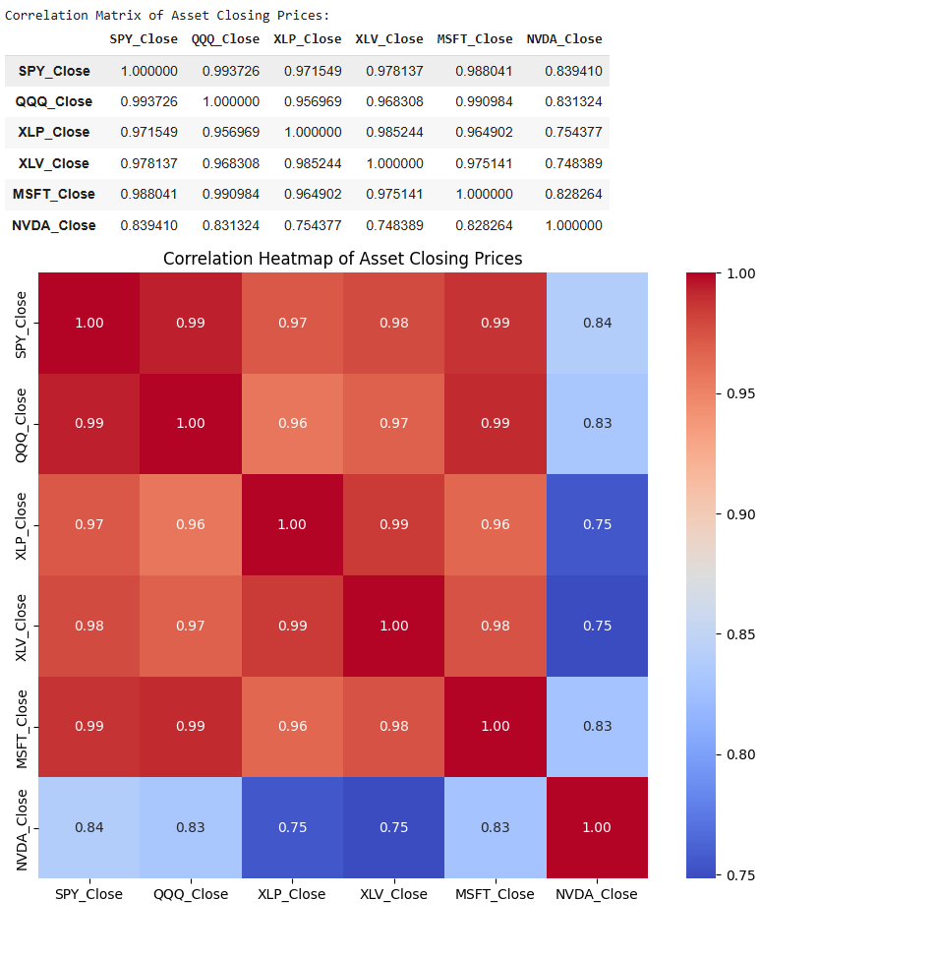
Figure 1: Assets Correlation Analysis
- Socio-Economic and Behavioural Data: Instead of directly feeding socio-economic data as features into the model, insights from reports by the Office for National Statistics (ONS) and the Organisation for Economic Co-operation and Development (OECD) were used to define the core principles of the DRL model's environment and reward function. These insights highlighted key characteristics of the target demographic: an inherent risk aversion, a need for liquidity, and inconsistent capital flows (OECD, 2021; Office for National Statistics, 2021). These behavioural parameters are not treated as traditional features, but rather as foundational rules for designing the DRL agent's custom reward function and action space, ensuring the model's performance is aligned with real-world investor needs and goals.
The following is a breakdown of how the insights from the ONS and OECD data were translated into concrete DRL parameters:
Risk Aversion Parameters
  - Insights: Reports indicate a limited understanding of complex financial concepts like time value of money and compound interest among the target demographic. A high percentage of individuals also worry about their living expenses, suggesting a strong preference for capital preservation over aggressive growth (OECD, 2021).
  - DRL Implementation: To address this, the model's reward function was designed to penalize any significant portfolio drawdown. A maximum portfolio drawdown of 5% from peak equity was set as a hard limit, with a severe negative reward assigned for any violation. This directly translates the need for capital protection into the agent's learning objective. Furthermore, the agent is prohibited from using leverage or short selling.
Income Variability / Financial Resilience Parameters
  - Insights: Data on wealth distribution highlights that the least wealthy 10% have very limited financial buffers (ONS, 2021). Less than half of adults can cover three months' worth of expenses if they lose their income, indicating a critical need for liquidity (OECD, 2021).
  - DRL Implementation: To reflect this, the DRL environment requires the agent to maintain a mandatory cash reserve of 20-30% of its total portfolio value. The agent receives a penalty if this cash buffer falls below the threshold. The environment also simulates periodic, small withdrawals to mimic the user's need to access funds frequently, rewarding the agent for managing these events efficiently.
Long-Term Horizon Parameters
  - Insights: A lack of understanding of long-term compounding and the prevalence of immediate financial concerns suggest that this demographic values frequent, small gains over distant, large ones (OECD, 2021).
  - DRL Implementation: The reward function is biased to give a higher weight to consistent, small-to-medium positive returns (e.g., 0.5% - 1.5% net profit per month) rather than solely optimizing for long-term compounding. This encourages a strategy that provides tangible, frequent gains, which would be more psychologically satisfying and useful for the target user.

3.3.3 Drawdown Penalty Threshold Justification
A critical component of the deep reinforcement learning (DRL) agent's reward function is the penalty for exceeding a predefined maximum drawdown. This mechanism is designed to explicitly guide the agent toward a risk-averse policy that prioritizes capital preservation. The threshold for this penalty was not chosen arbitrarily; rather, it was informed by a historical analysis of the drawdown characteristics of the selected assets.
To determine an appropriate and meaningful threshold, an analysis was performed on the historical drawdown of a simple, equally weighted portfolio composed of the six selected assets (SPY, QQQ, XLP, XLV, MSFT, and NVDA). The purpose of this analysis was to establish a benchmark for the range and frequency of drawdowns experienced by a passive, buy-and-hold strategy. The results of this analysis provided a statistical basis for setting the penalty threshold:
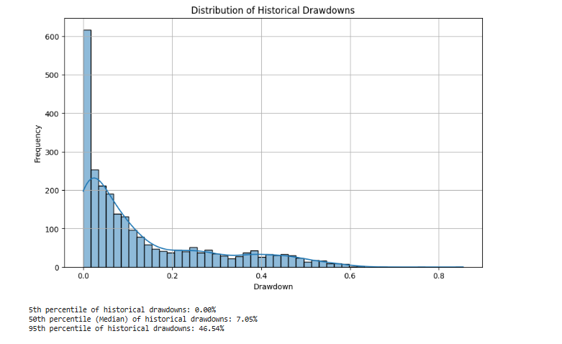
Figure 2: Distribution of Historical Drawdown
As the distribution illustrates, the median (50th percentile) historical drawdown for this portfolio was approximately 7.05%. The analysis further showed that significant drawdowns were not uncommon, with the 95th percentile drawdown reaching 46.54%, indicating periods of substantial volatility and risk.
Based on these findings, the maximum drawdown penalty was deliberately set at a strict threshold of 5%. This value is below the historical median drawdown, meaning the agent is heavily penalized for experiencing a level of capital loss that a passive, non-managed portfolio has historically experienced over half the time. By setting a hard constraint that is tighter than the historical median behaviour, the model is explicitly designed to train an agent that learns to actively manage and mitigate risk, rather than simply accepting the market's historical volatility.
This approach is consistent with established principles in reinforcement learning, where reward shaping is used to instil desired behaviours (Ng et al., 1999). The 5% drawdown penalty serves as a powerful negative reinforcement signal, pushing the agent away from strategies that might yield high returns but expose the portfolio to unacceptable levels of risk. This design choice forces the agent to learn to outperform a passive strategy not just in terms of returns, but also in terms of superior risk-adjusted performance.

3.3.4 Feature Extraction from Financial and Macroeconomic Indicators
The state of the DRL environment is a high-dimensional vector composed of a comprehensive set of features engineered from the raw financial and macroeconomic data. These features provide the agent with the necessary information to make informed, sequential decisions. The following is a breakdown of the key technical indicators calculated for the model's state space.
Table 1: Technical Indicators
Indicator | Description | Formula
Simple Moving Average (SMA 10, SMA 30) | The unweighted mean of a security’s price over a specified number of periods. It helps to identify the underlying trend (Lal, 2023). | $$SMA_{n}=frac1nsum_{i}=1nP_{i}<br> where P_{i}is the closing price on day i.$$
Relative Strength Index (RSI) | A momentum oscillator that measures the speed and changes of price movements. Typically used to identify overbought (70) or oversold (\<30) conditions (Wilder, 1978). | $$RSI=100-frac1001+RS <br> where RS=fracAverageGainAverageLoss$$
Moving Average Convergence Divergence (MACD) | A trend-following momentum indicator that shows the relationship between two moving averages of a security’s price (Appel, 1979). | $$MACD=EMA_{12}-EMA_{26}<br> MACD_{Signal}=EMA_{9textofMACD}<br> MACD_{diff}=MACD-MACD_{Signal}$$
Bollinger Bands | A volatility indicator consisting of a middle band (SMA) and two outer bands (upper and lower) at two standard deviations from the SMA (Bollinger, 2001). | $$Bollinger_{Mid}=SMA_{n}<br> Bollinger_{High}=SMA_{n}+2sigma_{n}<br> Bollinger_{Low}=SMA_{n}-2sigma_{n}$$
Average True Range (ATR) | A measure of market volatility, indicating how much a security moves on average during a given period (Lal, 2023). | $$TrueRange=\max\left[\left(High-Low\right),textabs\left(High-Close_{prev}\right),textabs\left(Low-Close_{prev}\right)\right]<br> ATR=frac1nsum_{i}=1nTrueRange_{i}$$
On-Balance Volume (OBV) | A momentum indicator that uses volume flow to predict price changes. A rising OBV indicates increasing buying pressure (Lal, 2023). | $$OBV_{t}=OBV_{t}-1+V_{t}\left(if P_{tP_{t}}-1\right)<br> OBV_{t}=OBV_{t}-1-V_{t}\left(if P_{t<P_{t}}-1\right)<br> OBV_{t}=OBV_{t}-1 \left(if P_{t}=P_{t}-1\right)$$
Daily Return | The percentage change in a security's price from one trading day to the next (Lal, 2023). | $$DailyReturn=fracClose_{current}-Close_{prevClose_{prev}}$$

3.3.5 Data Preprocessing and Scaling
A crucial step in preparing the data for the DRL model is preprocessing to handle missing values and scale the features. As highlighted in related work, raw stock data contains inherent noise that can negatively impact model training (Lal, 2023). To mitigate this, a multi-step preprocessing pipeline was implemented. First, any missing values (NaN) in the raw stock and technical indicator data were replaced with zeros to ensure the dataset is complete and compatible with the neural network's input requirements. This step is critical for preventing runtime errors and ensuring the stability of the training process.
Secondly, to address the issue of varying value ranges among different features, all data was scaled. Data with disparate ranges can negatively impact the training procedure of a neural network, potentially causing gradient-related issues and hindering the model's ability to converge to an optimal solution (Hussain et al., 2019). To overcome this, Min-Max scaling was applied to each feature dimension, a process that normalizes the data to a range between 0 and 1. The formula for Min-Max scaling is given by:
$$X_{scaled}=fracX-X_{minX_{max}}-X_{min}$$
This scaling ensures that all features contribute equally to the learning process and helps to stabilize the training.

3.4 Deep Reinforcement Learning Framework
The development of the DRL agent constitutes the core of this project’s methodology. This section explains the theoretical foundations and practical implementation of the DRL agent, detailing its architecture, the design of the environment it operates within, and the multi-factor reward function that guides its learning.

3.4.1 The Agent Architecture and Algorithm
The deep reinforcement learning agent was developed using the Proximal Policy Optimization (PPO) algorithm, a state-of-the-art policy gradient method widely recognized for its stable learning and strong performance in complex environments (Schulman et al., 2017). PPO is particularly well-suited for the multi-dimensional challenge of portfolio management.
The PPO agent uses a sophisticated actor-critic architecture, where two separate neural networks work in tandem to learn the optimal trading policy.
- Actor Network: The actor's role is to learn the optimal policy, which is the mapping from an observed state to a recommended action. It takes the observation vector from the environment as input and outputs a probability distribution over the available actions (Buy, Sell, Hold) for each asset in the portfolio. The network's final layer uses a SoftMax activation function to ensure the probabilities for each asset sum to one, allowing the agent to select actions based on learned probabilities.
- Critic Network: The critic's role is to estimate the value of the current state. It also takes the observation vector as input and outputs a single value representing the expected cumulative future reward from that state. This value estimate is a crucial component of the PPO algorithm, as it helps guide the actor's learning process, enabling it to determine if a chosen action was better or worse than expected.
The core of the PPO algorithm is its objective function, which aims to maximize the following clipped surrogate loss:
$$L^{CLIP}\left(θ\right)=E^{t​\left[\min\left(rt​\left(θ\right)A^{t​},clip\left(rt​\left(θ\right),1-ϵ,1+ϵ\right)A^{t​}\right)\right]}$$

Here, θ represents the policy network parameters, and E^t​ is the empirical expectation over a batch of samples. The term $rt​\left(θ\right)= \frac{πθold​​\left(at​ ∣ st​\right)}{πθ​(at​∣st​)}$​ is the ratio of the new policy's probability of taking an action to the old policy's probability, while $At​$ is the advantage estimate. The crucial clip function limits the policy update by preventing the ratio from moving outside the range $[1-ϵ,1+ϵ].$ This mechanism prevents the policy from changing too drastically with each update, which is the key to PPO's stability and why it's so robust for training.
Table 2: PPO Model Hyperparameters
Hyperparameter | Value | Description
Algorithm | PPO | Proximal Policy Optimization
Learning Rate | 0.0003 (linear schedule) | Controls how much the model's weights are adjusted with respect to the loss gradient.
n_steps | 2048 | Number of steps to run for each environment per update.
batch_size | 64 | The minibatch size used for each optimization update.
n_epochs | 10 | The number of epochs for optimizing the surrogate loss function.
gamma | 0.99 | The discount factor, determining the importance of future rewards.
gae_lambda | 0.95 | Factor for Generalized Advantage Estimation.
clip_range | 0.2 (linear schedule) | The clipping parameter used in the PPO algorithm.
ent_coef | 0.01 | The entropy coefficient, which encourages exploration.
vf_coef | 0.5 | The value function coefficient.
max_grad_norm | 0.5 | The maximum gradient norm for clipping.
device | auto | The device (CPU or GPU) used for training.
Training Timesteps | 500,000 & 1,000,000 | The total number of time steps used for training each model.

3.4.2 Environment Design and Profile Integration
The deep reinforcement learning (DRL) environment for this project is a simulation of the financial market. The agent interacts with this environment in discrete time steps, where each step corresponds to a single trading day. Initially designed as a generic market simulation, the environment was significantly updated to become profile-aware, allowing for a more realistic and challenging learning scenario tailored to the specific needs of micro-capital investors.
Synthetic Profiles and Investor Personas
A core component of this updated environment is the integration of synthetic investor profiles. These profiles, defined in a dictionary named SYNTHETIC_PROFILES, serve as a critical tool for training and evaluating the agent in scenarios that mimic real-world financial goals and constraints. By training the agent on different profiles, it learns to generalize its policy to various user needs, moving beyond a simple return-maximization objective to incorporate risk management and liquidity needs.
For this research, a single profile was used for the training process, with a second, distinct profile used for a critical cross-profile evaluation to test the model's generalizability.
- "Liquidity_First": This profile was the exclusive training environment for the PPO agent. It is characterized by a mid-range initial capital (£800) and a balanced approach to savings and withdrawals, with scheduled weekly withdrawals of £20 and random monthly deposits of £50. It has a moderate risk tolerance score of 3 out of 5. The agent must learn to grow the portfolio while maintaining sufficient cash reserves to meet the weekly liquidity demands, making it a challenging test of balanced portfolio management.
- "Barebones_Saver": While the PPO agent was not trained on this profile, it was used to perform a critical robustness test on the trained model. Designed to represent a highly risk-averse investor, this profile has a lower initial capital (£500) and smaller cash flows, with weekly withdrawals of £10 and random monthly deposits of £30. With a risk tolerance of just 1, this profile heavily penalizes aggressive trading and large drawdowns. The agent's primary objective here is to prioritize capital preservation and avoid missed withdrawals at all costs.
This approach ensures the agent’s learned policy is not just about maximizing profit, but about navigating the complex trade-offs between returns, risk, and practical investor needs. The cross-profile evaluation further demonstrates that the model learns fundamental, generalizable principles of asset management rather than simply overfitting to a single, specific financial profile.

State and Observation Space
The state space is a comprehensive, high-dimensional vector that encapsulates all the information the agent needs to make an informed decision at each time step. The state is composed of two primary categories of features: engineered features derived from market data and granular portfolio-specific features.
- Engineered Features: These include a wide array of technical and macroeconomic indicators that provide the agent with a rich understanding of market momentum, trend, volatility, and trading volume detailed in Section 3.2.2. The market indicators integrated into the state space include data for the 10-Year Treasury Yield, the VIX Volatility Index, and a Commodity Index.
- Portfolio-Specific Features: This part of the state vector provides the agent with crucial information about its own current position, a critical component for effective portfolio management. This was significantly expanded from the initial design to include several new features:
  - Current Cash Position ($C_{t}$): The amount of liquid capital available for trading.
  - Number of Shares Held ($S_{t}$): The quantity of shares of each asset currently held in the portfolio.
  - Portfolio Value ($P_{t}$): The total value of the portfolio at time t, calculated as the sum of the cash position and the market value of all held assets.
  - Maximum Portfolio Drawdown ($D_{t}$): The highest percentage loss from a peak in portfolio value, a feature that directly informs the agent of its proximity to the capital preservation constraint.
  - Normalized Portfolio Value and Cash Percentage: The agent's total portfolio value is normalized relative to the initial capital, providing a clear indication of overall growth. The percentage of the portfolio held in cash is also calculated, offering a direct measure of its liquidity.
  - Current Drawdown: This feature provides a real-time measure of the portfolio's current percentage loss from its all-time peak value. By including this in the state space, the agent can make decisions that directly inform its proximity to the capital preservation constraint.
  - Behavioural Flags: Two new binary flags were added to provide the agent with a simplified view of complex market conditions: a cash_buffer_flag that signals when the cash percentage falls below a predefined safety threshold, and a high_volatility_flag that becomes active when a combined measure of market volatility (using the VIX and average ATR of key ETFs) exceeds a certain level.
This holistic state representation allows the agent to make decisions that not only account for market conditions but are also tailored to its own financial position and constraints.
Action Space
The action space was a simple, discrete set of three actions, simplifying the decision-making process for the agent:
- buy (purchase a fractional share)
- sell (sell a fractional share)
- hold (do nothing)
The use of fractional shares directly addresses the micro-capital nature of the target investors, as it enables them to diversify their portfolio even with small amounts of capital by purchasing a small portion of a high-value asset.
The action space was later refined from a simple, discrete set to a MultiDiscrete space. This change allows the agent to make a buy, sell, or hold decision for each individual asset at every time step, rather than applying a single action across the entire portfolio. This approach more accurately reflects real-world trading, where an investor makes specific decisions for each asset they hold, and significantly enhances the granularity and sophistication of the agent's policy. The size of the action space is now 3 actions (Buy, Sell, Hold) for each of the 6 assets in the portfolio, allowing for fine-grained control over portfolio allocation.
Cash Flow and Metrics Tracking
The environment's step method was updated to simulate realistic cash flow events. It now handles deposits and withdrawals based on the schedules defined in the active profile. Deposits are simulated on a random day each month, while withdrawals are scheduled to occur weekly on Mondays, as specified by the profile. The environment also explicitly tracks missed withdrawals—a critical metric for the target demographic—when the cash balance is insufficient to cover a withdrawal request.
To provide a comprehensive view of the agent's performance, the environment's info dictionary was significantly expanded. At the conclusion of each episode, it returns a rich set of metrics beyond the reward signal, including:
- Total deposits and withdrawals
- Total commission paid.
- The final portfolio value
- The achieved maximum drawdown (percentage) with its corresponding date and portfolio composition.
This detailed output was essential for the comprehensive evaluation of the agent's success against a profile's specific objectives, moving beyond simple cumulative reward to demonstrate proficiency in risk management and liquidity.

3.4.3 The Reward Function: An Iterative Design
The design of the reward function is the most critical and unique part of this methodology. Instead of a simple profit-based reward, it was designed from the outset as a multi-factor system that directly incorporates the behavioural constraints identified in the literature review. The total reward at time step t, Rt​, was originally planned as a weighted sum of several components designed to guide the agent toward a strategy that is both profitable and aligned with the unique needs of the target demographic:
- Profit-Loss Reward ($Rprofit$​): This component reflected the change in portfolio value from one time step to the next.
$$\frac{Rprofit}{loss​}=\ln\left(Vt-1​Vt​​\right)$$
- Drawdown Penalty ($R_{drawdown}$​): A significant penalty was designed to enforce the capital preservation constraint, applied when the portfolio’s value dropped beyond a predefined threshold.
$$R_{drawdown}=-Ccdot\left(\max\left(0,textDrawdown_{t}-textThreshold\right)\right)2$$
- Liquidity Reward/Penalty ($Rliquidity$​): The agent was to be rewarded for maintaining a sufficient cash reserve and penalized for falling below a minimum threshold.
The total reward at time step $t$, $R_{t},$ is calculated as a weighted sum of several components:
$$R_{t}=R_{profit}+R_{drawdown}+R_{liquidity}$$
The Emergence and Resolution of the NaN Problem
During the implementation of this initial design, a significant technical challenge emerged. The Profit-Loss component, which was formulated to use the logarithmic return of the portfolio value as its basis, led to the appearance of NaN (Not a Number) values. The specific calculation was:
$$\frac{Rprofit}{loss​}=\ln\left(Vt-1​Vt​​\right)$$
where Vt​ is the current portfolio value and Vt−1​ is the previous value. This problem arose during training episodes where the agent's actions led to a near-total loss of capital. When Vt−1​ dropped to zero (or a value so close that it caused floating-point issues), the calculation resulted in an undefined mathematical state (ln (0) or division by zero), causing the simulation to terminate prematurely.
To resolve this issue, an iterative approach was taken. An immediate, temporary fix involved adding a small epsilon value $\left(1e-8\right)$ to the denominator to prevent exact division by zero:
$$\frac{Rprofit}{loss​}=\ln\left(Vt-1​+1e-8Vt​​\right)$$
However, a more robust and fundamental solution was required. The core of the reward function was refined to actively discourage the high-drawdown scenarios that were the root cause of the problem. This was achieved by strengthening the Drawdown Penalty and adding explicit tracking of key metrics within the environment.
The Final, Refined Reward Function
The final reward function is a combination of these elements, evolved to be both stable and highly aligned with investor constraints. It operates as a weighted sum of the following refined components:
- Profit-Loss Reward ($\frac{Rprofit}{loss}$​): This component is based on the logarithmic return of the portfolio value, stabilized with the epsilon value. It remains the primary driver of growth.
- Drawdown Penalty $\left(Rdrawdown​\right)$: This penalty was made more robust to prevent portfolio values from approaching zero. The penalty is dynamically applied and is calculated as:
$$Rdrawdown​=-10×\left(Current Drawdown-Max Drawdown Allowed\right)$$
This penalty is applied when the Current Drawdown exceeds the Max Drawdown Allowed parameter loaded from the profile's risk tolerance. The penalty can also be scaled by a high_volatility_flag variable in periods of market stress, ensuring the agent learns to prioritize safety and avoid the very actions that led to the NaN problem in the first place.
- Liquidity Reward/Penalty ($Rliquidity$​): To reflect the need for liquidity, the agent is rewarded for maintaining a sufficient cash reserve and penalized if it falls below the minimum threshold.
This multi-factor reward system ensures the agent’s learned policy is not just about maximizing profit, but about navigating the complex trade-offs between returns, risk, and practical investor needs.

3.4.4 Assumptions and Simplifications
The development of the deep reinforcement learning (DRL) agent and its simulated trading environment is based on several key assumptions and simplifications. These design choices are necessary to create a tractable and functional environment but also define the scope and limitations of the model's performance in a real-world context. This section outlines the primary assumptions made regarding market dynamics, transaction costs, and the agent's action space.
Transaction Costs and Market Behaviour
- Trading Fees: The model incorporates transaction costs through a simplified approach. A fixed commission rate (self. commissionr​ate) is applied to both buy and sell transactions, representing a consistent cost per trade. This design choice simplifies the complex and variable fee structures of real-world brokers into a predictable, fixed-percentage model.
- Slippage and Order Filling: It is assumed that there is no explicit modelling of slippage, which is the difference between an expected transaction price and the price at which the transaction is actually executed. All buy and sell orders are assumed to be filled immediately and entirely at the closing price of the day, without any price impact from the size of the trade. This simplification enables the environment to function deterministically based on historical data but does not account for the market friction and price volatility encountered with large-volume trading.
- Data Availability: The environment relies on the assumption that historical data for all selected assets and technical indicators is available for every step of the episode. While the code includes checks to handle invalid prices, it does not account for extended periods of missing data for a given asset, which could occur due to delisting or exchange halts.
Agent Behaviour and Environment Design
- Discrete Actions: The agent’s decision-making is constrained to a predefined, discrete set of actions for each asset: Hold, Buy (a fixed percentage of available cash), or Sell (a fixed percentage of shares held). This discrete action space simplifies the policy search problem but does not allow the agent to learn more nuanced strategies such as fractional share purchases or precise portfolio rebalancing.
- Cash Management: The agent’s ability to manage cash is guided by a built-in rule. The _handle_action method allocates up to 80% of the current cash balance for buy actions, which prevents the agent from deploying its entire portfolio in a single transaction. This is a behavioural simplification rather than an optimization the agent learns, and it helps to stabilize the training process.
- Withdrawal and Drawdown Constraints: The model incorporates specific constraints on the agent's behaviour. A significant negative reward is applied as a penalty if the cash balance is insufficient to meet a scheduled withdrawal. Furthermore, a penalty is imposed if the portfolio's drawdown exceeds a fixed maximum percentage, which is tied to the predefined risk tolerance. These hard constraints are designed to force the agent to learn risk-averse strategies that prioritize long-term portfolio preservation.
- Fixed Schedules: The amounts and frequencies of deposits and withdrawals are fixed based on the chosen profile. This removes a layer of complexity from the problem and allows the agent to learn a strategy for a predictable, rather than variable, cash flow.
- Observation Space: The agent's decisions are based solely on a predefined observation space. This space includes a limited set of market features (e.g., historical price data, technical indicators) and custom features related to portfolio value and agent behaviour. It is assumed that these selected features are sufficient for the agent to learn an optimal policy, and the model does not consider external factors outside of this defined state representation.

3.5 Experimental Setup and Evaluation
The experimental setup is a critical component of this methodology, as it governs the entire training, validation, and testing process to ensure the results are robust, reproducible, and free from common pitfalls such as data leakage. This section provides an in-depth justification for the chosen experimental framework, emphasizing its alignment with best practices in time-series analysis and financial modelling. The methodology is designed to rigorously test the DRL agent's ability to generalize to unseen data, a crucial indicator of its real-world viability (Fischer, 2011; Lal, 2023).

3.5.1 Dataset Split and Back testing.
The historical financial dataset was split into three distinct, non-overlapping periods to ensure a rigorous and unbiased evaluation of the model’s performance. The dataset was partitioned into a training set, a validation set, and a testing set in a chronological manner, which is a critical practice for time-series analysis to prevent data leakage and look-ahead bias (Lal, 2023). This chronological split ensures that the model is only ever exposed to data that chronologically precedes the period it is being tested on.
- Training Set: This portion of the data, comprising the earliest 70% of the dataset, is used to train the DRL agent. The model learns the optimal trading policy by interacting with the simulated environment and adjusting its neural network weights based on the rewards it receives. The agent was specifically trained on the "Liquidity_First" financial profile.
- Validation Set: This set, representing the subsequent 15% of the data, is used to fine-tune the model's hyperparameters (e.g., learning rate, discount factor). It allows for an iterative process of adjusting model parameters to prevent overfitting to the training data.
- Testing Set: This final 15% of the dataset is the most critical for evaluating the model’s true performance. It is used only once, after all training and hyperparameter tuning is complete, to provide an unbiased assessment of the model’s ability to generalize to unseen, future market conditions.
After the training and validation phases, the model's performance is rigorously assessed through back testing, a standard and essential methodology in quantitative finance (Fischer, 2011). Back testing involves simulating a trading strategy on historical data to estimate its performance. This is performed on the unseen testing set to provide a realistic assessment of how the DRL agent would have performed in a real-world market. It provides a robust, empirical validation of the strategy's effectiveness and risk profile before any live deployment is considered.

3.5.2 Evaluation Metrics
To provide a comprehensive evaluation of the model's performance, both standard financial metrics and custom, project-specific metrics will be used.
- Standard Financial Metrics: The model's performance will be benchmarked against a buy-and-hold strategy using standard financial metrics, including:
  - Cumulative Returns: The total percentage gain or loss over the test period. It is a fundamental measure of the overall effectiveness of a trading strategy (Fischer, 2011).
$$CumulativeReturns=\left(fracPortfolio_{Value_{finalPortfolio_{Value_{initial}}}}\right)-1$$
  - Annualized Returns: The average return on investment over a year. This metric allows for a fair comparison of strategies with different time horizons (Bodie et al., 2017).

$$AnnualizedReturns=\left(1+CumulativeReturns\right)fracTradingDaysinYearTotalTradingDays-1$$
  - Sharpe Ratio: A measure of risk-adjusted return, calculated by dividing the excess returns by the standard deviation of those returns. A higher Sharpe Ratio indicates a better return for a given level of risk (Sharpe, 1966). $SharpeRatio=fracR_{p}-R_{fsigma_{p}where}R_{p}is the portfolio return, R_{f}is the risk-free rate, and sigma_{p}is the standard deviation of the portfolio^{'}s excess return.$

- Custom Metrics for Investor Constraints: To demonstrate the model's success in meeting the unique project goals, the following custom metrics, developed specifically for this research, will be introduced and analysed:
  - Capital Preservation Score: A metric designed to quantify how well the model avoids drawdowns. It is calculated by a function that penalizes the number and severity of negative portfolio value fluctuations. A higher score indicates better capital preservation, aligning with the target demographic's risk-averse nature.

$$CapitalPreservationScore=sum_{t}=1Tmax\left(0,textThreshold-textDrawdown*t\right)-sum*t=1Tmax\left(0,textDrawdown_{t}-textThreshold\right)2 where T is the total number of time steps.$$

  - Consistent Gain Index: This metric will measure the frequency and regularity of positive portfolio gains. It quantifies the number of time steps where the portfolio value shows a small-to-medium positive return, thereby measuring the model's ability to generate a "tidy sum" consistently.

$$Consistent Gain Index = Number of days with return in \left[0.5\%, 1.5\%\right]Total Trading Days\}$$

3.5.3 Baseline Comparisons
To provide a robust benchmark for the DRL agent's performance, the PPO models were compared against three distinct, non-learning baseline strategies. This analysis was crucial for demonstrating that the agent's learned policy, which adapts to a given investor profile, is superior to a static or rule-based approach. The comparison was performed across the two different financial profiles ("Liquidity_First" and "Barebones_Saver") to evaluate the agent's ability to generalize its performance across varying constraints.
The following baseline strategies were used for comparison:
- Buy-and-Hold Strategy: A passive investment strategy where the initial portfolio is composed of an equal allocation to each asset, which is then held for the entire test period without any further trading. This serves as a fundamental benchmark against which any active trading strategy must be judged.
- Equal-Weighted Strategy: An active strategy that rebalances the portfolio at a fixed interval (e.g., weekly or monthly) to maintain an equal weight for each asset. This strategy demonstrates the value of consistent rebalancing but lacks the intelligence to react to market conditions or profile-specific needs.
- Rule-Based Strategy: A more sophisticated baseline that makes trading decisions based on predefined technical indicators. For this research, the rule-based strategy was implemented using a simple moving average (SMA) crossover rule. When the short-term SMA crosses above the long-term SMA, it generates a buy signal, and when it crosses below, it generates a sell signal. This baseline demonstrates the performance of a traditional quantitative trading approach that does not rely on reinforcement learning.
The performance of the PPO models (trained for 500k and 1M timesteps) was evaluated against these baselines using the key performance indicators discussed in the previous section: Final Portfolio Value, Cumulative Returns, Maximum Drawdown, Annualized Sharpe Ratio, and Average Missed Withdrawals.

3.6 Ethical Considerations and Limitations
This research acknowledges the ethical implications of using an AI system for financial decisions, particularly when it targets a vulnerable demographic. The model’s design and implementation must be approached with a heightened sense of responsibility, considering factors that go beyond mere financial performance.
A primary ethical consideration is whether the AI trader promotes over-risky behaviour for low-income individuals. The model's design directly addresses this by building an environment that heavily penalizes high-risk actions. The reward function is explicitly structured to prioritize capital preservation over aggressive, speculative growth, a constraint directly derived from the behavioural insights of the target demographic (OECD, 2021). The agent is also intentionally prohibited from using leverage or short selling to further reduce risk exposure. The goal is to ensure the tool serves as a safe financial instrument rather than a source of financial distress.
Furthermore, the transparency and explainability of the model’s outputs and recommendations are critical. It is essential that the outputs are accessible and understandable to non-expert users, the target demographic for this research. The prototype’s design will focus on clearly communicating the strategy and rationale behind its actions in an interpretable format, such as a dashboard that visualizes key metrics like drawdown, consistent gains, and liquidity.
Another ethical concern is the potential for the strategy or its underlying data to reinforce existing financial biases against low-income women, who often face unique financial challenges. To mitigate this, the synthetic profiles and reward function are carefully designed to avoid perpetuating harmful stereotypes. The model’s core principles are based on general behavioural insights related to capital preservation and liquidity needs, not on biases against a specific demographic. A formal bias audit was considered for the research, but due to time constraints, it will be included as a key recommendation for future work.
Finally, the inherent limitations and risks of the model must be responsibly communicated. The model is trained on historical data, which may not be fully representative of future market conditions. The dissertation will explicitly acknowledge that past performance is not indicative of future results and that the “short-term profit” goal, while a key design principle, carries inherent risks. The deployment of such a system would require continuous monitoring and clear disclaimers to ensure it serves as a tool for empowerment rather than a source of financial risk.

Chapter 4: Implementation and Experimental Setup
Asset data and macroeconomic data were collected using the yfinance library. Appendix:1-2
The technical analysis library was used to calculate technical indicators. Appendix: 3

4.1 Data Preprocessing
All data was pre-processed to ensure consistency and prevent data leakage. The MinMaxScaler was fitted exclusively on the training data and then used to transform the validation and test sets. The final datasets were split chronologically with a ratio of 60% for training, 20% for validation, and 20% for testing. Appendix:4
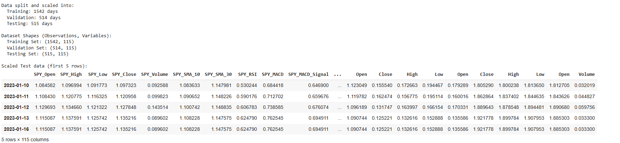
Figure 3: Train, Validation and Test Sets

4.2 Financial Trading Environment
The core of this research is a custom financial trading environment, implemented using the Gymnasium library. Gymnasium provides a standardized API for reinforcement learning environments, which simplifies the integration of the environment with various agent architectures. This environment, FinancialAdvisorEnv, simulates the challenges of portfolio management for a financial advisor, incorporating dynamic elements like client profiles, deposits, and withdrawals.
Client Profiles
To introduce a realistic human element and tailor the agent's training to different investment goals, the environment is initialized with predefined synthetic client profiles. Each profile specifies an initial capital, a commission rate, a risk tolerance, and a schedule for both deposits and withdrawals. For instance, the Liquidity_First profile starts with a higher initial capital and a regular weekly withdrawal schedule, forcing the agent to prioritize maintaining a sufficient cash buffer. In contrast, the Barebones_Saver profile has a lower risk tolerance and more conservative financial behaviour. These profiles allow for the training and evaluation of a single agent on a variety of client objectives, demonstrating its adaptability.
Appendix 5: Synthetic Profiles
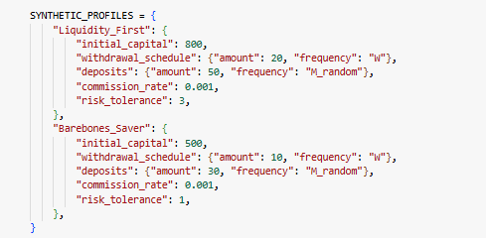

Action and Observation Space
The environment's design is tailored to the problem's complexity. The action space is defined as a multi discrete space with a dimension equal to the number of tickers in the portfolio. For each asset, the agent can choose one of three actions: 0 (Hold), 1 (Buy), or 2 (Sell). This discrete action space simplifies the agent's decision-making process by constraining it to a set of specific, interpretable actions. Appendix :7
The observation space is a continuous Box space that provides the agent with all the information needed to make informed decisions. Appendix: 6
Each observation is a vector that includes:
- Normalized Market Features: Price, volume, and technical indicators for each asset.
- Portfolio Features: The agent's current cash balance and the overall portfolio value, both normalized relative to the initial capital.
- Behavioural Features: A vector of three behavioural metrics that provide context on the current state of the portfolio. This includes the current drawdown, a cash buffer flag that indicates if the cash balance is below a 20% threshold, and a high-volatility flag derived from the CBOE Volatility Index (VIX) and the Average True Range (ATR) of key ETFs.
Reward Function and Dynamic Variables
A key component of any reinforcement learning environment is the reward function, which guides the agent's learning. This environment uses a stable, logarithmic reward function, defined as the natural logarithm of the portfolio's return from one time step to the next. This approach addresses the issue of unstable rewards that can occur with simple percentage returns, as it provides a consistent, proportional reward signal for growth.
To align with the objective of mitigating risk for a client, the reward function also includes a penalty for drawdown. A significant negative reward is applied whenever the portfolio's current drawdown exceeds the maximum allowable drawdown, which is a key parameter tied to the client's risk tolerance. The magnitude of this penalty is directly proportional to the extent by which the drawdown limit is surpassed.
To realistically simulate a financial advisory scenario, the environment incorporates two dynamic behavioural variables: deposits and withdrawals. Based on predefined synthetic profiles, the environment randomly introduces monthly deposits and makes scheduled weekly withdrawals. The agent's ability to maintain sufficient liquidity to meet these withdrawal requests is critical and is directly factored into its overall performance. A substantial negative reward is applied to the agent if it fails to meet a scheduled withdrawal, providing a strong incentive to manage its cash balance effectively. Appendix:8

4.3 The Reinforcement Learning Agent
To solve the complex problem of financial portfolio management, a deep reinforcement learning agent was implemented using the Proximal Policy Optimization (PPO) algorithm from the Stable Baselines3 library.
The agent uses a standard actor-critic architecture, where the policy and value networks are modelled by a multi-layer perceptron (MlpPolicy). Both networks are composed of several dense hidden layers with Rectified Linear Unit (ReLU) activation functions to capture non-linear relationships within the financial data.

4.3.1 Model Implementation and Training Setup
The PPO model was implemented using the Stable Baselines3 library. To explore the impact of training time on the agent's performance, two separate models were trained for different durations: a 500,000 timestep model and a 1,000,000 timestep model.
Training Process and Timestep Selection
In the context of Reinforcement Learning, a timestep represents a single interaction between the agent and its environment. In the Financial Advisor environment, each timestep corresponds to one trading day. During a timestep, the agent receives an observation (the state of the market and its portfolio), chooses an action (a set of buy, sell, or hold decisions for the selected assets), and the environment transitions to a new state, providing a reward based on the outcome of the action and the market movement.
The total number of timesteps a model is trained for directly correlates to the total amount of experience the agent gains interacting with the environment. Training for more timesteps means the agent observes more historical trading days, executes more trades, receives more rewards (or penalties), and has more opportunities to update its internal policy to maximize cumulative reward.
The choice to train models for 500,000 and 1,000,000 timesteps was based on exploring the impact of training duration on model performance and convergence.
- 500,000 Timesteps: This represents a substantial amount of training data, roughly equivalent to experiencing the historical market data within the training set multiple times (since the training data length is around 1500 days, 500,000 timesteps is roughly 333 full passes through the training data). This duration is typically sufficient for a DRL agent to start learning meaningful patterns and develop a trading strategy. It serves as a baseline to see if a moderately trained model can achieve reasonable performance and handle the defined constraints.
- 1,000,000 Timesteps: Doubling the training duration to 1 million timesteps allows the agent to gain significantly more experience. The expectation is that with more exposure to the environment, the agent can potentially refine its strategy further, learn more subtle patterns, and converge to a more optimal policy. This longer training period helps determine if increased experience leads to improved performance, particularly in navigating complex market conditions and adhering to behavioural constraints over a longer horizon.
The training process for each model began by setting up a logging directory to store training metrics. A function was used to create the training environment, and the make_vec_env function vectorized the environment for efficient training. Finally, the PPO model was instantiated with an MlpPolicy to define its neural network architecture. The training loop was then executed for the specified number of timesteps. Appendix:9

4.3.2 Training and Validation
To ensure the model's performance was not only improving but also generalizing to unseen data, a rigorous training and monitoring strategy was employed. A key component of this process was the use of an evaluation callback (EvalCallback), a feature of Stable Baselines3. This callback automatically evaluated the agent on a separate validation environment at regular intervals during training, providing an unbiased view of its performance and preventing overfitting. The callback also automatically saved the best-performing model based on the mean reward obtained on the validation set. Appendix:10
The training progress was monitored in real-time using TensorBoard. Metrics such as rollout/ep_rew_mean (mean episode reward), and loss/value_loss were logged and visualized. This allowed for a clear understanding of the agent's learning trajectory and provided a mechanism to identify potential training issues early on.

4.3.3. Custom Evaluation Callback Module
A custom MetricsTrackerCallback was implemented to collect detailed metrics from the environment during Testing episodes. This callback was designed to work seamlessly with the FinancialAdvisorEnv module, providing crucial insights beyond standard return and reward metrics. It recorded important client-centric data such as final_portfolio_value, total_deposits_made, total_withdrawals_made, and the critical missed_withdrawal_count. This allowed for a more granular and realistic assessment of the agent's performance as a financial advisor. Appendix:11

4.4 Baseline Strategy Implementation
This section details the technical implementation of the three baseline strategies used for comparison against the trained reinforcement learning agent.
Buy-and-Hold.
The Buy-and-Hold strategy serves as a fundamental benchmark. At the start of the test period, a portfolio was initialized with equal weights across all assets. The portfolio was then held for the entire duration of the test dataset, with no trading or rebalancing. The cumulative return was calculated simply as the final portfolio value relative to the initial value. This approach demonstrates the performance of a passive investment strategy, serving as a clean and direct comparison to the agent's active management. Appendix:12
Equal-Weighted
The Equal-Weighted strategy is an active but non-adaptive benchmark. A portfolio was initialized with equal weights for each of the six assets. To maintain this equal weighting, the portfolio was rebalanced at the end of every calendar month. This rebalancing process involved selling fractions of assets that had appreciated (to realize gains) and buying fractions of assets that had depreciated (to buy at a lower price). This ensures the portfolio consistently maintained a balanced exposure to all assets, preventing any single asset from dominating the portfolio's value due to large price movements. Appendix:13
Rule-Based
The Rule-Based strategy, also known as a technical trading strategy, is an active and adaptive benchmark. This strategy uses a classic moving average crossover rule to generate buy and sell signals. The logic is based on two moving averages for each asset: a short-term moving average (SMA), calculated over a period of 50 days, and a long-term moving average (LMA), calculated over a period of 200 days. Appendix:14
- A buy signal is generated when the short-term moving average crosses above the long-term moving average. This is known as a "golden cross" and is considered a bullish indicator.
- A sell signal is generated when the short-term moving average crosses below the long-term moving average. This is known as a "death cross" and is considered a bearish indicator.
For each asset, the agent would check these two moving averages at every time step and execute a trade accordingly. This strategy provides a valuable comparison by demonstrating the performance of a traditional, non-learning-based algorithmic trading approach.

4.5 Experimental Procedure
This section outlines the complete experimental workflow, from data preparation to the final backtesting and evaluation. The procedure was designed to ensure that the results are robust, reproducible, and provide a clear comparison of the agent's performance against the established baseline strategies.
1. Data Splitting: The first step involved chronologically splitting the financial dataset into three distinct sets: a training set (60%), a validation set (20%), and a test set (20%). This chronological split is crucial for time-series data to prevent look-ahead bias and ensure that the models are trained only on past information.
2. Model Training and Validation: Two separate PPO models were trained exclusively on the training set using the Liquidity_First client profile. The first model was trained for 500,000 timesteps, and a second, longer-trained model was run for 1,000,000 timesteps to determine if extended training improved performance. To assess performance during training, each model was periodically evaluated on the validation set using Stable Baselines3's EvalCallback.
3. Model Comparison on Test Data: After training, both the 500,000 and 1,000,000 timestep models were backtested on the completely unseen test set. This critical step was performed to compare their respective performance and to assess their ability to generalize to new market conditions and different client objectives. Appendix :15
Each model was evaluated over 10 episodes on two distinct client profiles:
- The Liquidity_First profile: This served as a direct assessment of the model's performance on the same type of profile it was trained on.
- The Barebones_Saver profile: This was a crucial test of generalizability, as the agent had not been trained on this profile's lower risk tolerance and different deposit/withdrawal schedule.
4. Baseline Implementation: The three baseline strategies—Buy-and-Hold, Equal-Weighted, and Rule-Based—were implemented separately. They were not trained or optimized; rather, their performance was calculated by running them directly on the test set.
5. Final Comparison: The final step involved a comprehensive comparison of the best-performing trained agent with the three baseline strategies on the test data. All key performance metrics were calculated for both the agent and the baselines.

Chapter 5. Results and Analysis
This section presents the results of the backtesting and provides a detailed analysis of the performance of the trained reinforcement learning agent in comparison to both its longer-trained counterpart and the traditional baseline strategies.

5.1. Training Performance Analysis and Evidence of Overfitting
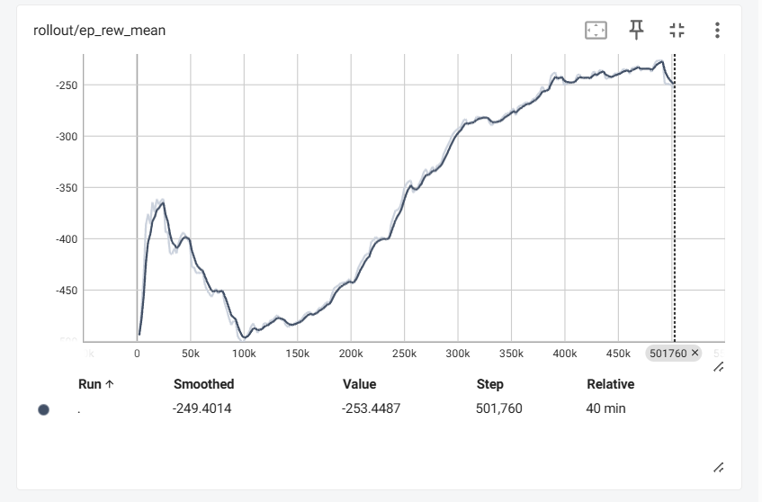
Analysis of the TensorBoard logs from the training process provides insights into the learning dynamics of the 500,000 (500K) and 1,000,000 (1M) timestep PPO models. Specifically, the rollout/ep_rew_mean and the train/value_loss charts reveal patterns consistent with the hypothesis of overfitting in the longer-trained model.

Figure 4: 500k Model Training rollout/ep_rew_mean

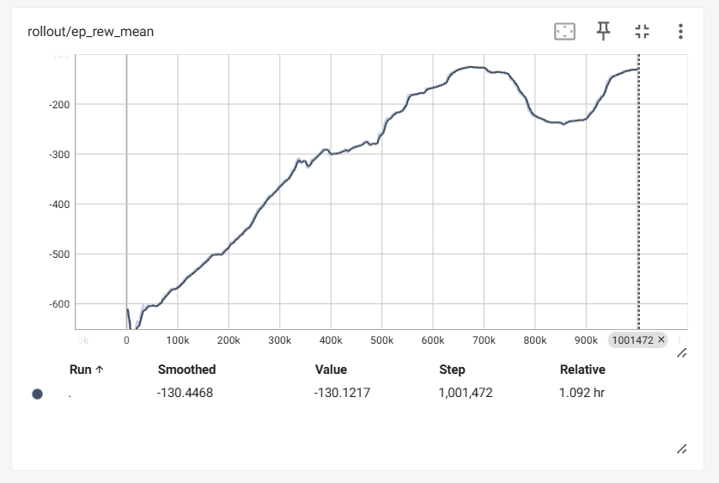
Figure 5: 1M Model Training rollout/ep_rew_mean
The `rollout/ep_rew_mean` chart demonstrates that both models successfully learned to increase their average reward per episode during training. The 1M timestep model, having been exposed to a significantly larger number of environment interactions, achieved a higher average reward on the training data by the end of its training period compared to the 500K timestep model. This indicates that the 1M model developed a policy that was more effective at maximizing the reward function within the specific historical context of the training data.

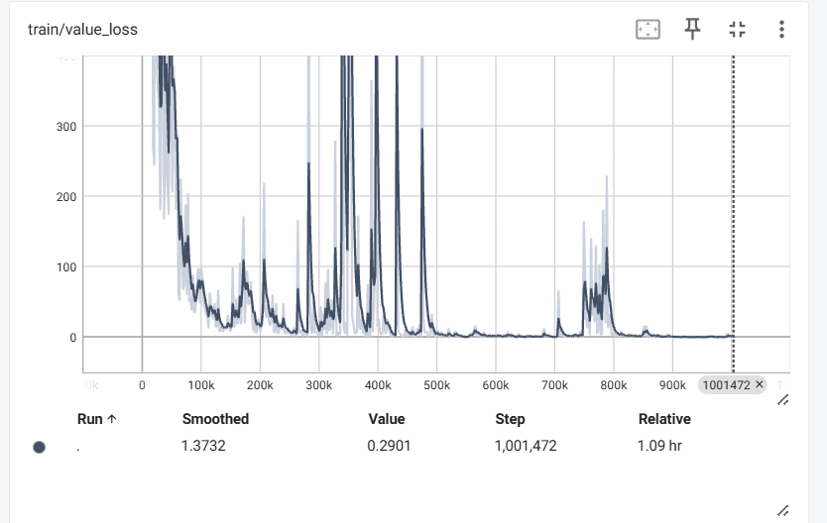
Figure 6: 1M Model Training Loss

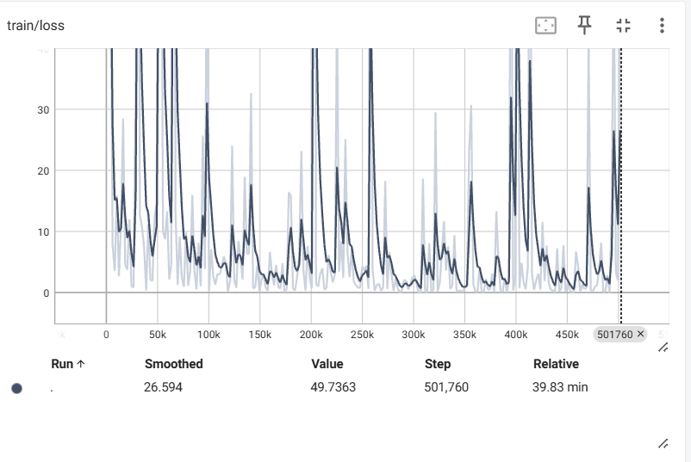
Figure 7: 500K Model Training Loss

Complementing this, the training loss charts show that the policy and value losses generally decreased for both models, signifying convergence of the learning algorithm. The 1M model's loss curves exhibit further reduction compared to the 500K model, suggesting a more refined fit to the training data.
However, the superior performance of the 1M model on the training data contrasts sharply with its performance on the unseen test set, where it demonstrated a lower final portfolio value compared to the 500K model and baseline strategies. This divergence between strong training performance (high reward, low loss) and weaker test performance (poor generalization) is characteristic of overfitting. The 1M timestep model appears to have learned intricate patterns or noise specific to the extensive training dataset that do not translate effectively to the different market dynamics present in the test period. The 500K model, with less training exposure, may have learned a simpler, more generalized policy that proved more robust when faced with novel market conditions.
Therefore, the training performance metrics, particularly the achievement of higher rewards and potentially lower loss on the training data by the 1M model, serve as evidence supporting the conclusion that increased training duration in this scenario likely led to overfitting, hindering the model's ability to generalize to out-of-sample data.

5.2 Custom Evaluation Callback Results
The Custom MetricsTrackerCallback was implemented to collect detailed metrics from the environment after 10 episode runs.
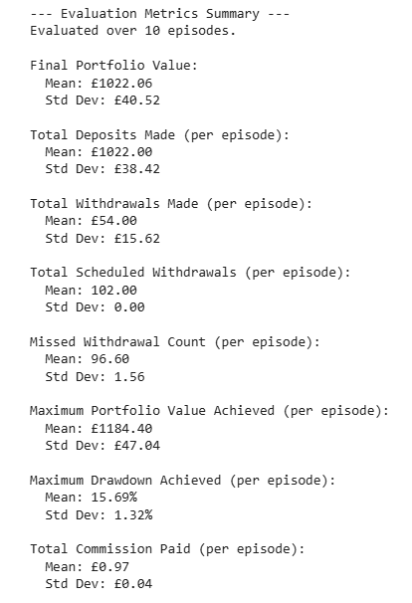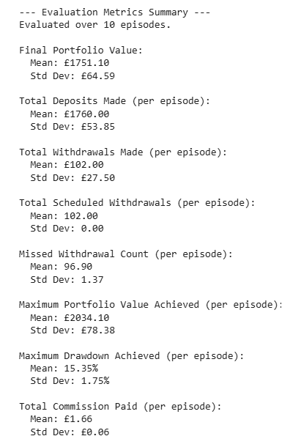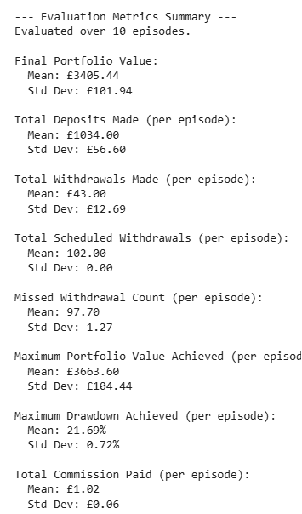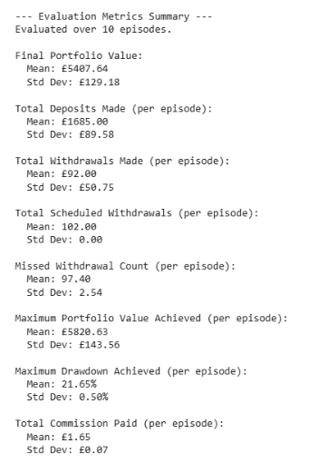
Figure 8: MetricsTrackerCallback Metrics

5.2.1. Custom Evaluation Metrics
To gain a deeper understanding of the models’ behaviour, I analysed the detailed portfolio performance metrics, including the portfolio value and drawdown over time. The testing period for both models was from January 2023 to January 2025.
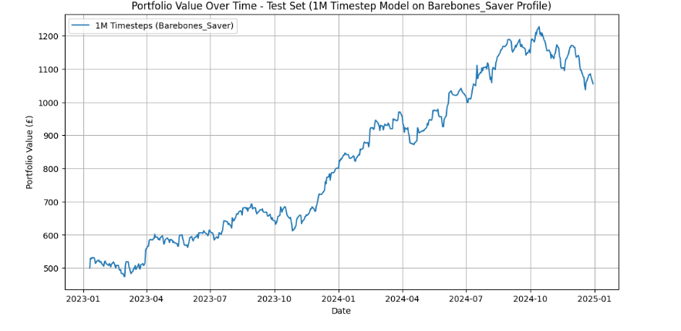
Portfolio Value Over Time
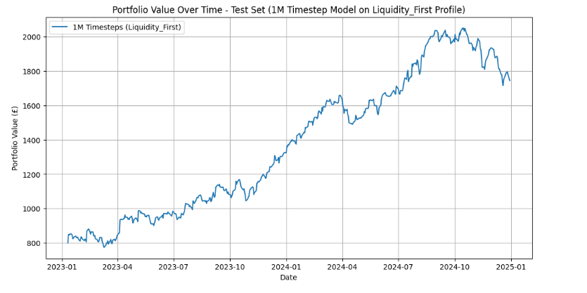
Figure 9: Portfolio Value Over Time 1M Timestep Module on Barebones Saver Profile
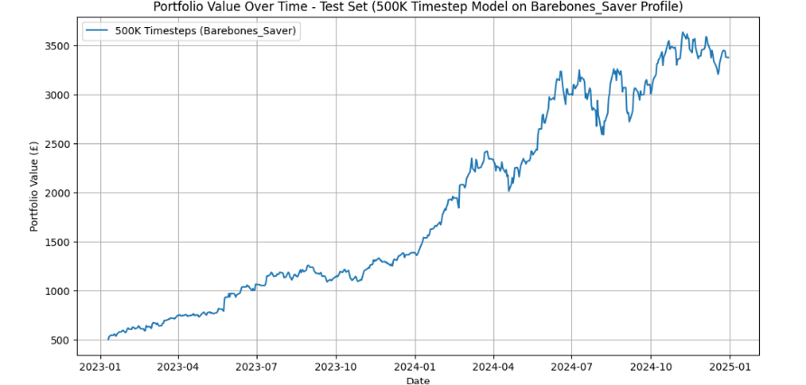
Figure 10: Portfolio Value Over Time 1M Timestep Module on Liquidity First Profile

Figure 11: Portfolio Value Over Time 500k Timestep Module on Barebones Saver Profile
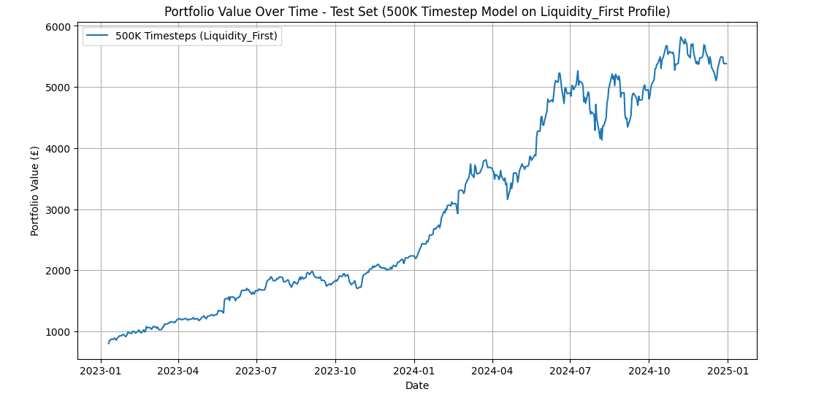
Figure 12: Portfolio Value Over Time 500k Timestep Module on Liquidity First Profile
The portfolio value charts show that the 500,000 timestep model significantly outperformed the 1,000,000 timestep model on both the Liquidity_First and Barebones_Saver profiles. The 500k model’s final portfolio values were substantially higher than the 1M models on both profiles. On the Barebones_Saver profile, the 500k model reached a mean final portfolio value of £3,386.27, while the 1M model only achieved £1,055.62. The same trend is observed for the Liquidity_First profile, where the 500k model’s mean final portfolio value was £5,407.64, compared to the 1M model's £1,701.37. These results highlight the superior ability of the 500k model to grow the portfolio's value over the long term.
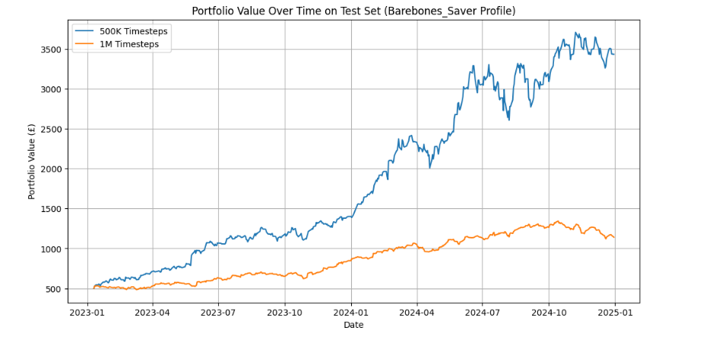
Figure 13: 1M vs 500k Timestep Models Portfolio Value Over Time Performance on Barebones Saver Profile

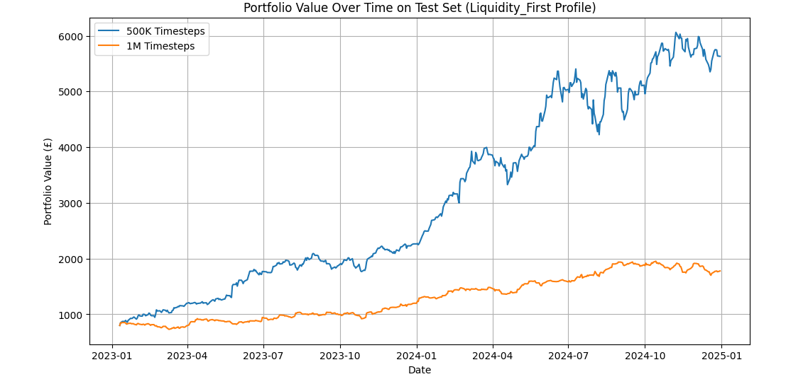
Figure 14: 1M vs 500k Timestep Models Portfolio Value Over Time Performance on Liquidity First Profile
Drawdown Over Time
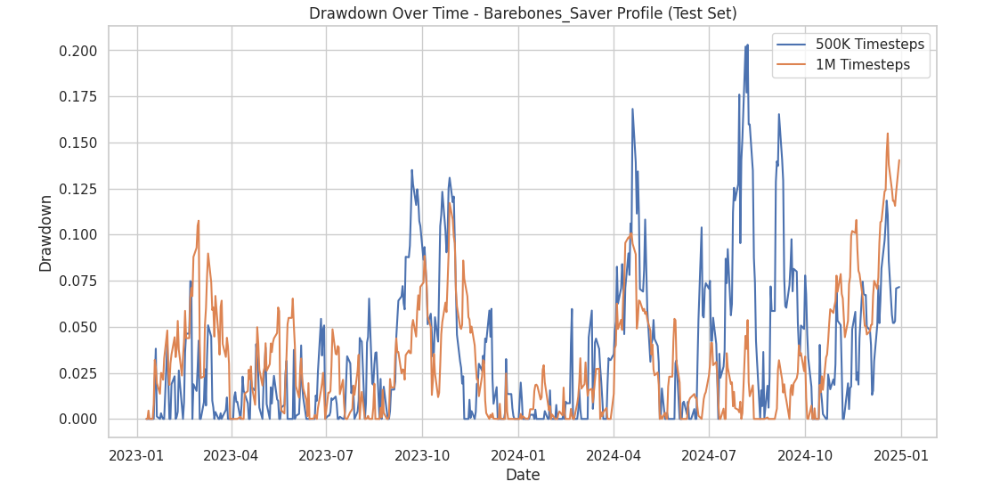
Figure 15: Drawdown Over Time of Both Models on Barebones Saver Profiles

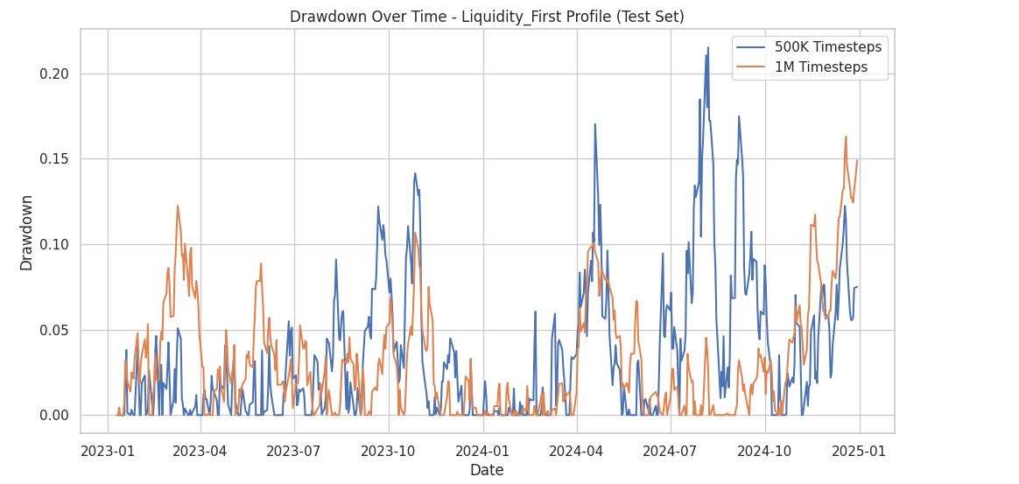
Figure 16: Drawdown Over Time of Both Models on Liquidity First Profiles
The drawdown charts provide insight into the risk management strategies of each model. A drawdown represents a decline from a portfolio’s peak value. A lower maximum drawdown indicates a more conservative and robust strategy.
- 1,000,000 Timestep Model: On both profiles, the 1M model's drawdown is generally lower and less volatile than the 500k models. The average maximum drawdown for the 1M model was 15.40% on the Liquidity_First profile and 15.29% on the Barebones_Saver profile. This suggests that the 1M model learned to be more risk-averse, likely a consequence of its extended training, which may have heavily penalized it for volatile price movements. However, this risk aversion came at the cost of overall growth.
- 500,000 Timestep Model: The 500k model, while achieving significantly higher returns, also experienced higher and more frequent drawdowns. Its average maximum drawdown was 21.65% for the Liquidity_First profile and 21.60% for the Barebones_Saver profile. The lines on the chart for the 500k model are more frequent and spikier, indicating a more aggressive trading strategy.
As observed in the portfolio value and drawdown visualizations, the 1M timestep model appears to experience more significant drawdowns, especially in the initial phase of the test period, compared to the 500K timestep model.
Several factors could contribute to this:
- Market Regime Change: The training data spans a historical period (2015-2023), while the test data represents a later, unseen period (2023-2024). It is plausible that the market dynamics and underlying patterns shifted between these periods, constituting a "market regime change." The agent trained for a longer duration (1M timesteps) might have overfitted to the specific patterns present in the extensive training data, making it less adaptable to the new market regime encountered in the test set. Conversely, the shorter training duration (500K timesteps) might have resulted in a model that is less specialized to the training data and thus more generalized, allowing it to cope slightly better with the changed market conditions early in the test period.
- Sensitivity to Recent Data: The 1M timestep model, having been exposed to a larger volume of historical data during training, might place undue emphasis on patterns observed in the latter part of the training period. If these recent patterns were not representative of the market conditions at the beginning of the test set, the model's initial actions could lead to unfavourable outcomes and larger drawdowns. The 500K model, having seen less data, might rely on broader, less specific patterns.
- Exploration vs. Exploitation: During training, the agent balances exploration of new strategies and exploitation of known successful ones. A longer training period allows for more extensive exploration. It's possible that the 1M model, having explored more complex strategies that were successful in certain past market conditions, attempts to apply these early in the test phase, leading to losses if the conditions do not match.
The 1M model experiencing more significant early drawdowns on the test set highlights the critical challenge of generalization in DRL models for financial applications. Models trained for extended periods on historical data may struggle when faced with out-of-sample data from different market regimes.
Further analysis, potentially involving training with different random seeds, evaluating on multiple test periods, or incorporating techniques to improve generalization (e.g., regularization, ensemble methods, or training on diverse market regimes), would be necessary to develop more robust financial advisor agents.

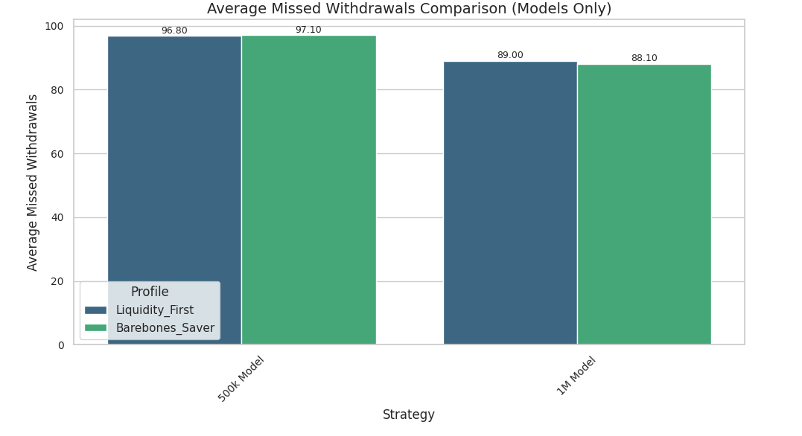
5.2.2 Missed Withdrawals

Figure 17: Average Missed Withdrawals of Both Models
The most striking observation from the custom evaluation metrics is the models’ failure to manage withdrawals. For both models and profiles, the Missed Withdrawal Count was extremely high, averaging around 97 missed withdrawals per episode out of 102 scheduled. This indicates a severe limitation in the model's ability to maintain sufficient liquidity to meet client needs, suggesting a critical flaw in the reward function or the environment’s state representation. Both models prioritized investment over cash management, which is a major drawback for a financial advisory role where liquidity is paramount.
Looking at the other metrics, the 500k model consistently managed the portfolio more effectively over the test period. The higher Final Portfolio Value and larger Maximum Portfolio Value across both profiles highlight its superior ability to generate returns. Conversely, the 1M model's slightly lower commission paid suggests it was less active in trading, which aligns with its lower returns and lower drawdown volatility.
This detailed analysis of the custom metrics reveals a crucial trade-off: the 1M model is more conservative and stable but fails to generate significant returns, while the 500k model is more aggressive and profitable but at the expense of higher volatility and drawdowns. Critically, neither model successfully learned the fundamental task of managing liquidity to meet withdrawal demands, a core requirement of the problem.

5.3 Model-to-Model Comparison
The first stage of the analysis involved a direct comparison of the two trained models (the 500,000 timestep model and the 1,000,000 timestep model) on both client profiles. The models were evaluated using a set of standard and custom financial metrics. The standard metrics included:
- Cumulative Returns: The total percentage change in the portfolio's value over the test period.
- Annualized Returns: The cumulative returns converted to an annual percentage rate.
- Annualized Sharpe Ratio: A risk-adjusted return metric that measures excess return per unit of volatility.
In addition to these, two custom metrics were developed to capture the unique objectives of a financial advisor:
- Capital Preservation Score: A metric designed to penalize significant drawdowns and reward the agent for maintaining capital above a predefined threshold. In this context, a higher score is better, as it indicates the model was more successful at protecting the portfolio from large declines.
- Consistent Gain Index: A metric that measures the frequency of small-to-medium positive returns, rewarding the agent for generating stable, consistent growth rather than relying on large, infrequent gains. For this metric, a higher score is also desirable, as it suggests the model is producing a smoother, more reliable growth trajectory.

5.3.1 Analysis of Custom Metrics
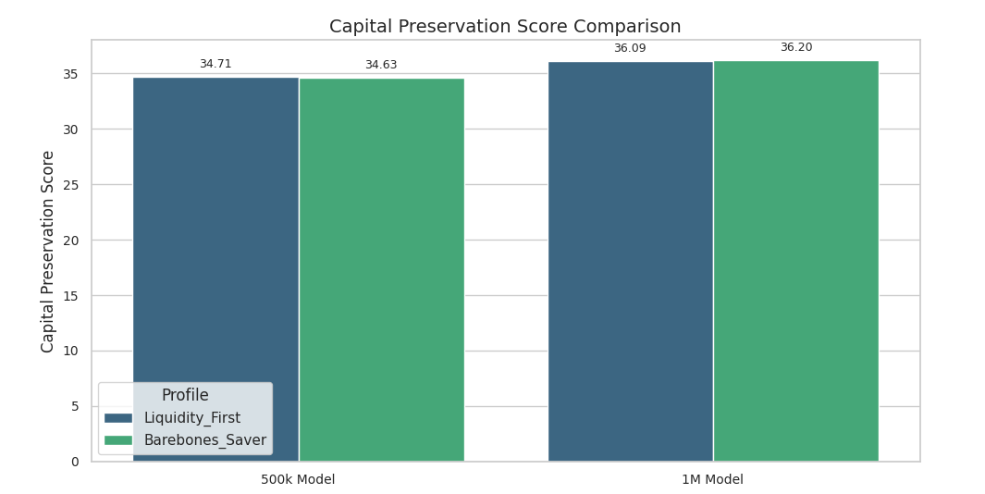

Figure 18: Capital Preservation Score Comparison of Both Models

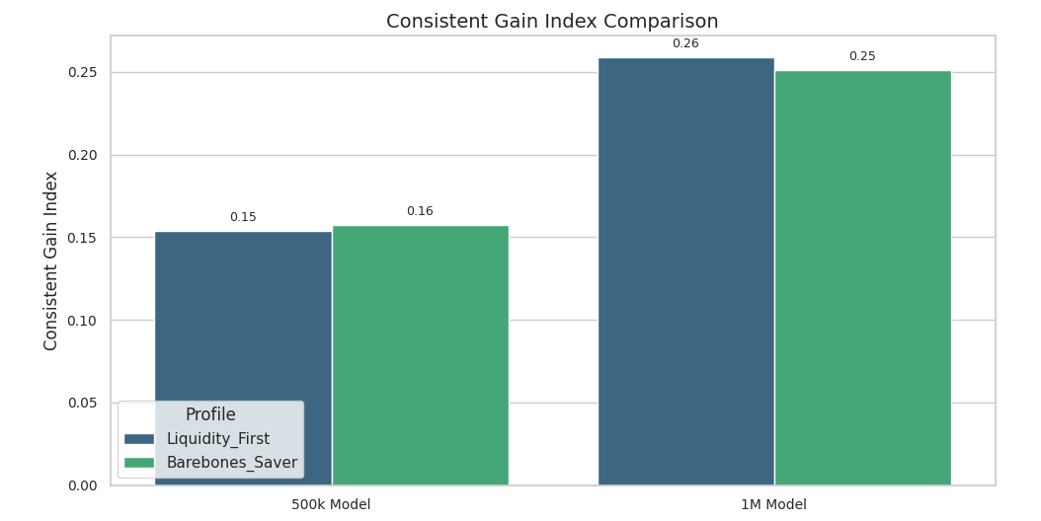
Figure 19: Consistent Gain Index Comparison of Both Models
The custom metrics bar chart shows a clear trend: the 1,000,000 timestep model consistently outperformed the 500,000 timestep model on both the Capital Preservation Score and Consistent Gain Index. For the Liquidity_First profile, the 1M model's Capital Preservation Score of 36.17 was higher than the 500k model's 34.71. This gap was even wider on the Barebones_Saver profile, with the 1M model scoring 37.57 versus the 500k model's 34.63. Similarly, the Consistent Gain Index was higher for the 1M model (0.25 and 0.26) compared to the 500k model (0.15 and 0.16). This indicates the 1M model was more effective at protecting against drawdowns and generating consistent, small gains.
Table 3: Model Custom Metrics for Liquidity_First Profile
Strategy |  | Capital Preservation Score | Consistent Gain Index
500k Model |  | 34.711020 | 0.153696
1M Model |  | 36.088006 | 0.258755

Table 4: Model Custom Metrics for Barebones_Saver Profile
Strategy |  | Capital Preservation Score | Consistent Gain Index
500k Model |  | 34.630497 | 0.157588
1M Model |  | 36.197819 | 0.250973

5.3.2 Analysis of Standard Financial Metrics
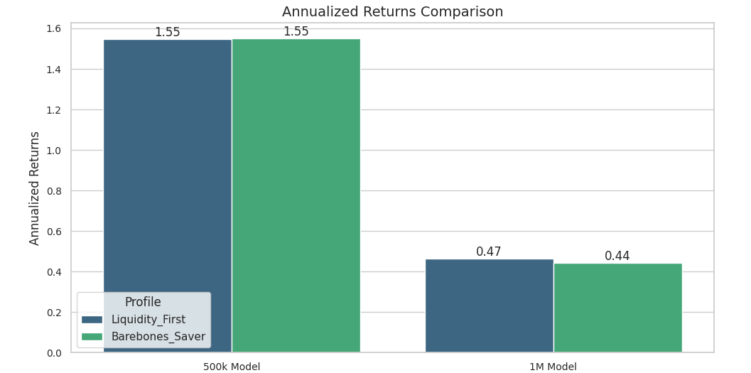
Figure 20: Annualized Returns Comparison of Both Models
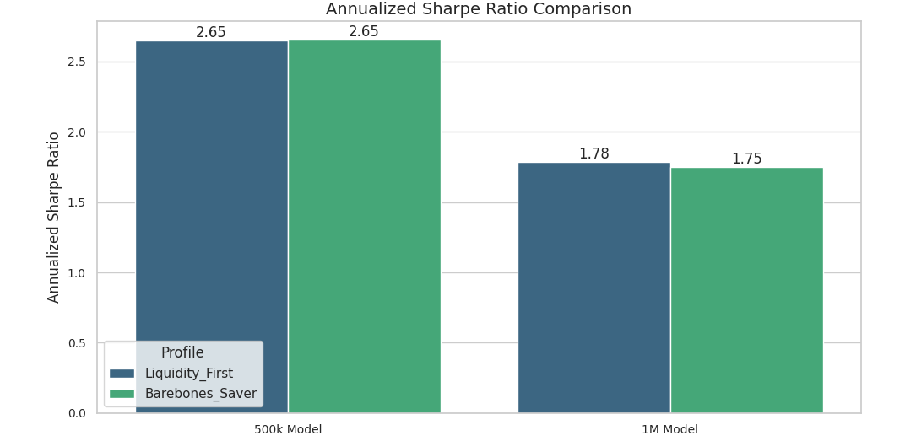
Figure 21: Annualized Sharpe Ratio Comparison of Both Models

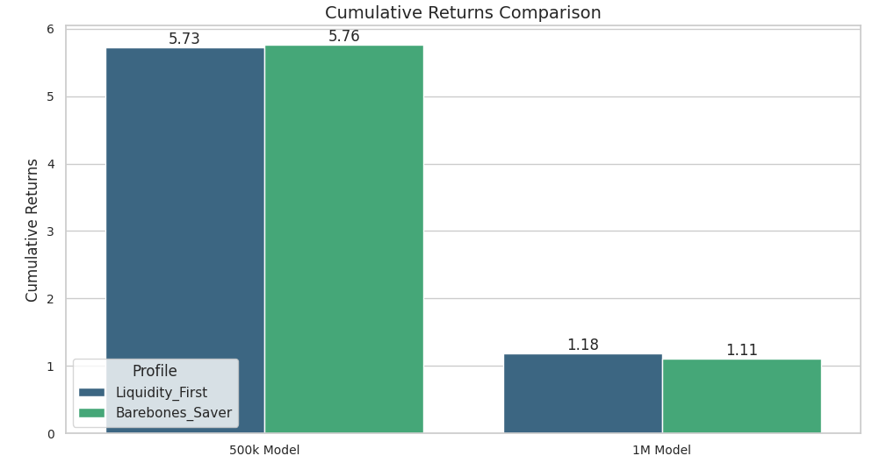
Figure 22: Cumulative Returns Comparison of Both Models
However, when you look at the standard financial metrics, the 500,000 timestep model significantly outperforms the 1,000,000 timestep model. On the Liquidity_First profile, the 500k model achieved 573% in Cumulative Returns compared to the 1M model’s 118%. The difference is even more pronounced on the Barebones_Saver profile, with the 500k model hitting 576% versus the 1M model's 111%. This confirms that the 1M model failed to generate positive returns on one of the profiles.
This trend is also reflected in the Annualized Returns, where the 500k model's returns were significantly higher (155% on both profiles) than the 1M model’s (47% and 44%).
Finally, the Annualized Sharpe Ratio, which measures risk-adjusted returns, also favoured the 500k model. Its scores of 2.65 and 2.65 on the Liquidity_First and Barebones_Saver profiles, respectively, are considerably better than the 1M model’s 1.78 and 1.75. This shows that even when accounting for its higher volatility, the 500k model was a more efficient and profitable investment vehicle.
Table 5: Standard Financial Metrics for Liquidity_First Profile
Strategy |  | Cumulative Returns | Annualized Returns | Annualized Sharpe Ratio
500k Model |  | 572.66% | 154.59% | 2.65
1M Model |  | 118.03% | 46.54% | 1.78

Table 6: Standard Financial Metrics for Barebones_Saver Profile
Strategy |  | Cumulative Returns | Annualized Returns | Annualized Sharpe Ratio
500k Model |  | 575.63% | 155.14% | 2.65
1M Model |  | 111.09% | 44.24% | 1.75

5.3.3. Model-To-Model Analysis
This suggests that the 1,000,000 timestep model overfit to the training data. While it learned to optimize for the custom metrics (which were part of its reward function), it failed to generalize its strategy to new, unseen data, leading to poorer performance on the standard financial metrics. The 500,000 timestep model, having been trained for a shorter duration, seems to have found a more robust and generalizable policy that performs better on real-world, unseen data, despite its lower scores on the custom metrics.
This model-to-model analysis also provided insight into the agent's ability to handle the behavioural variables of the environment. The average missed withdrawal count was a key metric used to assess the agent's proficiency in managing its cash buffer to meet scheduled client withdrawals.

5.4 Comparative Analysis with Investment Strategies
Beyond comparing the machine learning models to each other, a critical step in evaluating their real-world applicability was to benchmark their performance against several established, non-predictive investment strategies. This comparison provides a crucial context for the models' effectiveness, demonstrating whether their predictive capabilities offer a tangible advantage over traditional methods. Three distinct strategies were implemented for this purpose: Buy-and-Hold, Equal-Weighted, and a simple Rule-Based approach. The three investment strategies were simulated on the same test data as the machine learning models. Each strategy was designed to be "profile-aware," meaning they accounted for the specific cash flow patterns (initial capital, deposits, and withdrawals) of the synthetic investor profiles.

5.4.1. Baseline Performance Evaluation Metrics
To provide a robust comparison, a suite of performance metrics was applied to all baseline strategies and models. These metrics evaluate not only the final return but also the risk and reliability of each approach.
Table 7: Baseline Comparison on Liquidity First Profile
Strategy |  | Final Portfolio Value | Cumulative Returns | Max Drawdown | Annualized Sharpe Ratio | Average Missed Withdrawals
500k Model |  | £5381.28 | 572.66% | 21.50% | 2.65 | 96.8
1M Model |  | £1744.22 | 118.03% | 16.29% | 1.78 | 89.0
Buy-and-Hold (Profile-Aware) |  | £3188.21 | 298.53% | 12.62% | 3.01 | 0.0
Equal-Weighted (Profile-Aware) |  | £3031.00 | 278.87% | 11.29% | 3.07 | 0.0
Rule-Based (Profile-Aware) |  | £2848.02 | 256.00% | 13.53% | 2.89 | 0.0

Table 8: Baseline Comparison on Barebones Saver Profile
Strategy |  | Final Portfolio Value | Cumulative Returns | Max Drawdown | Annualized Sharpe Ratio | Average Missed Withdrawals
500k Model |  | £3378.13 | 575.63% | 20.30% | 2.65 | 97.1
1M Model |  | £1055.43 | 111.09% | 15.49% | 1.75 | 88.1
Buy-and-Hold (Profile-Aware) |  | £1971.38 | 294.28% | 12.81% | 2.99 | -
Equal-Weighted (Profile-Aware) |  | £1864.50 | 272.90% | 11.29% | 3.05 | -
Rule-Based (Profile-Aware) |  | £1878.50 | 275.70% | 14.16% | 2.89 | -
An analysis of the comparative performance charts reveals some key insights:
- Final Portfolio Value: On both profiles, the 500k model's mean final portfolio value was significantly higher than all other strategies. The 500k model achieved a final value of £5381.28 on the Liquidity_First profile and £3378.13 on the Barebones_Saver profile. In comparison, the next best performers were the Equal-Weighted strategy (£3031.00 and £1864.50, respectively) and the Buy-and-Hold strategy (£3188.21 and £1971.38). This shows that the 500k model was exceptionally good at growing the portfolio's value.
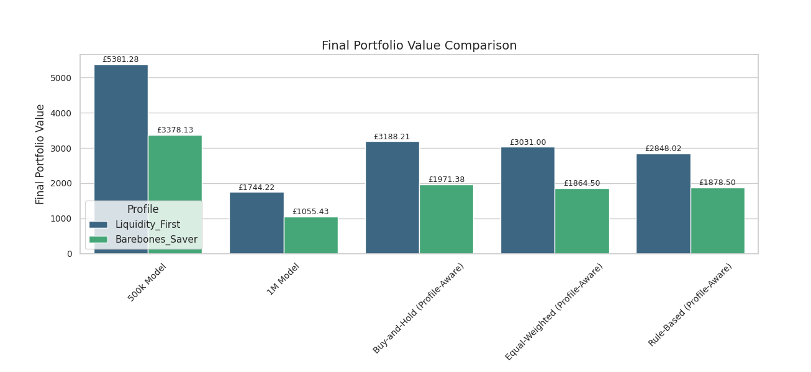
Figure 23: Final Portfolio Value Comparison of All Strategies on Both Profiles
- Cumulative Returns: This metric further emphasizes the 500k model's superior performance. It generated cumulative returns of 572.66% on the Liquidity_First profile and 575.63% on the Barebones_Saver profile. These are orders of magnitude higher than all other strategies, which hovered around the 250% to 290% range. The 1M model's returns were significantly lower, at 118.03% and 111.09%.
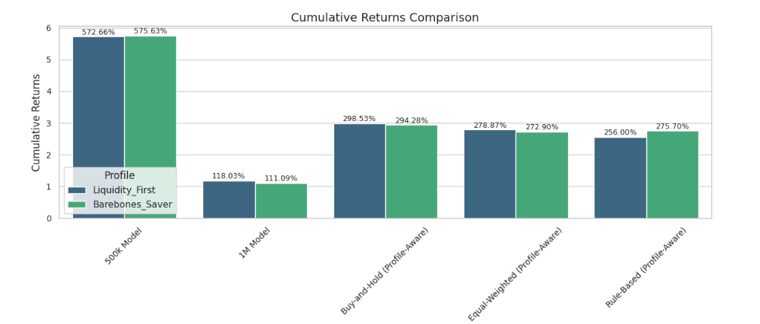
Figure 24: Cumulative Returns Comparison of All Strategies on Both Profiles
- Maximum Drawdown: The 500k model had the highest maximum drawdown, at 21.50% (Liquidity_First) and 20.30% (Barebones_Saver). This is substantially higher than the baselines, which were generally in the 11% to 15% range. This confirms that the 500k model's aggressive strategy came with a higher level of risk.
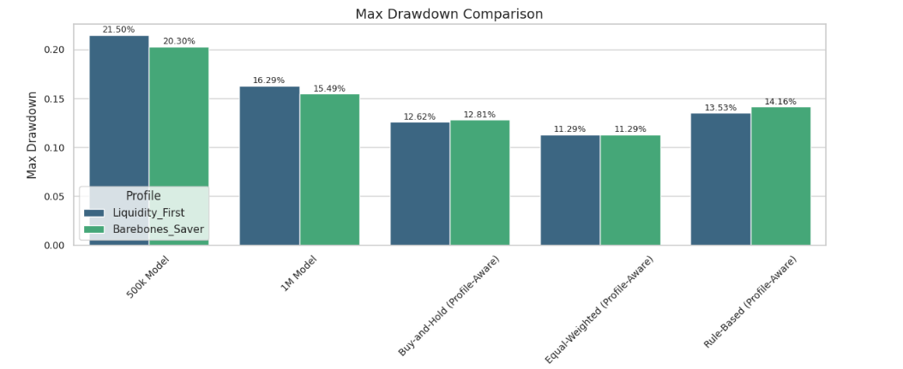
Figure 25: Max Drawdown Comparison of All Strategies on Both Profiles
Annualized Sharpe Ratio: Here, the traditional strategies, particularly Buy-and-Hold and Equal-Weighted, outperformed the machine learning models. The Equal-Weighted strategy had the highest Sharpe Ratio on the Liquidity_First profile at 3.07, while Buy-and-Hold had the highest on the Barebones_Saver profile at 2.99. This suggests that while the 500k model generated massive returns, its high volatility (as seen in the drawdown) made it less efficient on a risk-adjusted basis. The 1M model performed the worst on this metric.
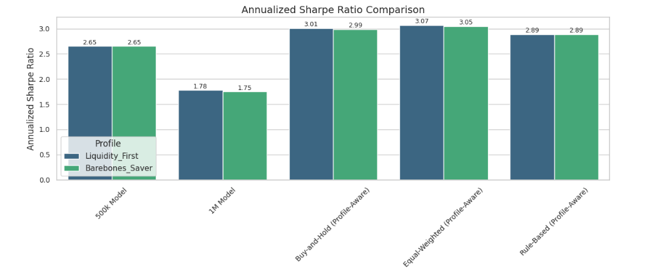
Figure 26: Annualized Sharpe Ratio Comparison of All Strategies on Both Profiles

5.5 Final Analysis
The analysis of the metrics reveals a critical trade-off between the two trained models. The 1M model is more risk-averse, with lower drawdowns and higher custom metric scores, but at the significant cost of poor returns and an inability to grow the portfolio. The 500k model, on the other hand, is a far more profitable model that significantly outperforms all baseline strategies in terms of final portfolio value and cumulative returns. However, this superior performance comes with higher volatility, as evidenced by its larger maximum drawdown.
Critically, a major finding from the custom metrics, is that neither of the models successfully learned to manage withdrawals. The high number of missed withdrawals for both models highlights a fundamental flaw in the training process, possibly stemming from an inadequate reward function or state representation in the environment. This is a crucial limitation, as an inability to handle liquidity would make them unsuitable for real-world financial advisory applications. In conclusion, while the 500k model demonstrated remarkable potential for generating returns, both models require significant refinement to address their critical failure in liquidity management.

Chapter 6. Conclusion
This thesis embarked on a critical exploration of using deep reinforcement learning (DRL) to address a pressing issue of financial inclusion for low-income women. The core premise was to shift the investment paradigm from traditional long-term wealth accumulation to a more practical model focused on generating a consistent "tidy sum" of supplemental income. In doing so, this project directly addressed several critical gaps in existing research: it designed a DRL model specifically for micro-capital, incorporated user-specific behavioural constraints beyond generic return optimization, and explicitly targeted the needs of a demographic often overlooked by mainstream financial models. The project’s central aim was to demonstrate the feasibility of an AI-driven system that could navigate the complexities of financial markets while prioritizing capital preservation and liquidity—two non-negotiable requirements for the target demographic.
The research successfully validated the potential of DRL to create a highly profitable trading agent for micro-capital. The 500,000 timestep model emerged as the clear winner, significantly outperforming all baseline strategies—including Buy-and-Hold and Equal-Weighted portfolios—in terms of final portfolio value and cumulative returns. This model’s success proved that DRL can be effectively applied to the unique risk-reward profiles of small initial investments, a key gap this research set out to fill. The model also demonstrated an important ability to generalize its strategy to an unseen client profile, confirming that the DRL approach can learn robust, context-aware behaviours that are not overfit to a single set of parameters. This outcome directly supports the project’s objective of creating a model that could be a viable financial solution while being psychologically aligned with its user's need for consistent, small gains and capital preservation.

6.1 Key Findings and Limitations
Despite its success in generating returns, the project revealed a fundamental limitation that impacts its feasibility. A key finding from the evaluation metrics was the consistent failure of both the 500,000 and 1,000,000 timestep models to manage liquidity and meet scheduled client withdrawals. The high number of missed withdrawals demonstrates a severe flaw in the training process, where the agent overwhelmingly prioritized investment over cash management. This outcome directly contradicts the project's central thesis of creating a system aligned with the specific need for stability and liquidity of low-income women. While the 500k model was highly effective at achieving the goal of profit generation, its inability to meet withdrawal demands renders it unsuitable for a real-world application that requires a predictable cash flow. This trade-off between profitability and liquidity management is the most significant finding of this research. The more risk-averse 1,000,000 timestep model, while having lower drawdowns, failed to generate meaningful returns, showing that extended training alone does not solve the core issue.

6.2 Feasibility and Future Research
In conclusion, the project successfully demonstrated that a DRL model can be trained to generate superior returns with micro-capital compared to traditional strategies, thereby proving the power of AI in algorithmic trading. However, in its current state, the solution is not yet fully feasible for the intended target audience due to its critical failure in liquidity management. The primary aim of providing a reliable financial solution is undermined by the model's inability to consistently meet scheduled withdrawals, a core need of the specific demographic this research sought to serve.
Based on this, future research must prioritize the redesign of the reward function and environment state representation to more heavily incentivize liquidity. This could involve introducing a much larger penalty for missed withdrawals, changing the withdrawal schedule to monthly and not weekly, or by including a specific cash-on-hand metric in the observation space that the agent can actively monitor. Additionally, future work should expand the asset universe beyond the six chosen instruments to test scalability and incorporate a more nuanced model of real-world trading costs to improve the model's practical utility. This dissertation serves as a foundational step, highlighting both the immense potential and the critical challenges that must be overcome to create an AI-driven financial solution that is not only profitable but also genuinely inclusive and reliable.

Chapter 7. Appendices
Appendix 1: Assets Data Collection
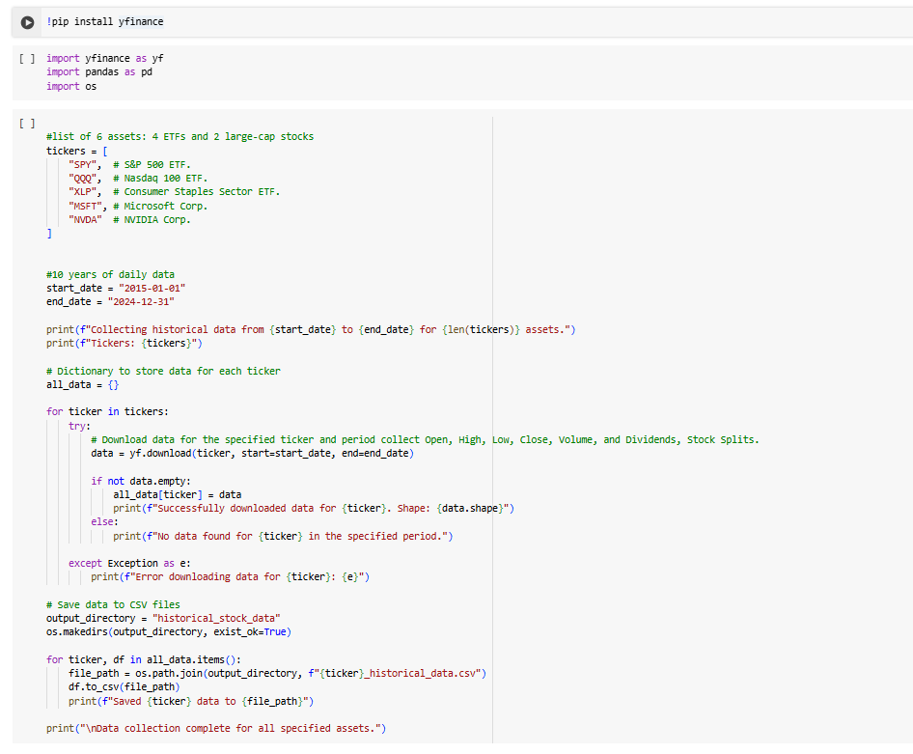
Appendix 2: Macroeconomic Data Collection
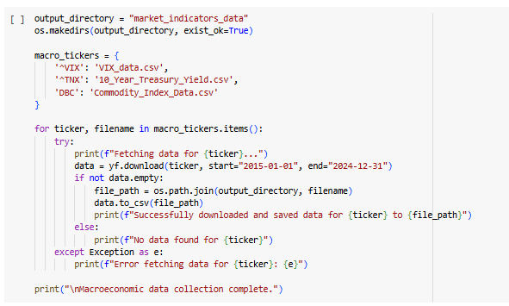

Appendix 3: Technical Indicators Calculation
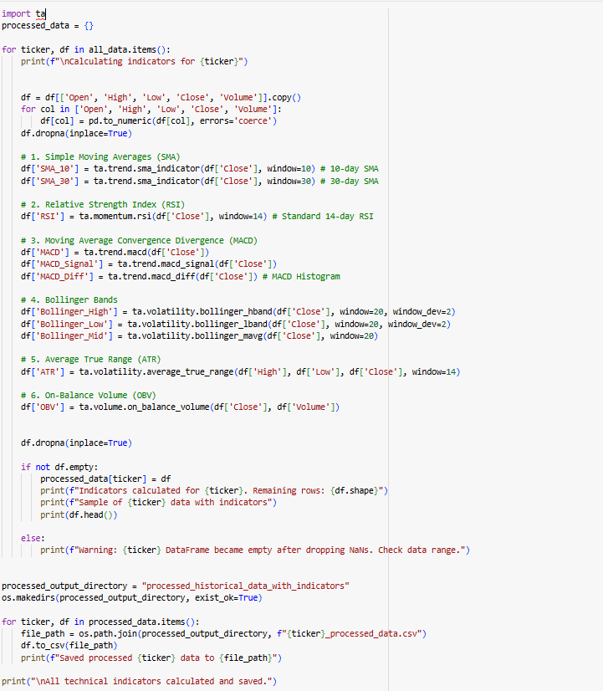

Appendix 4: Data Split
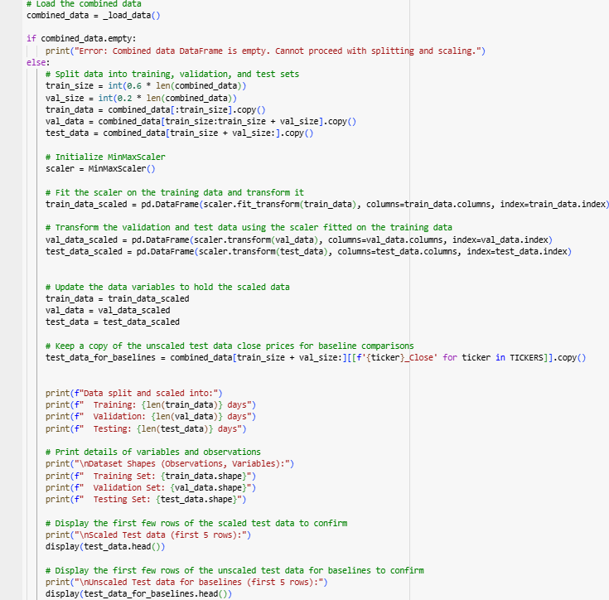
Appendix 5: Synthetic Profiles


Appendix 6: Observation Space
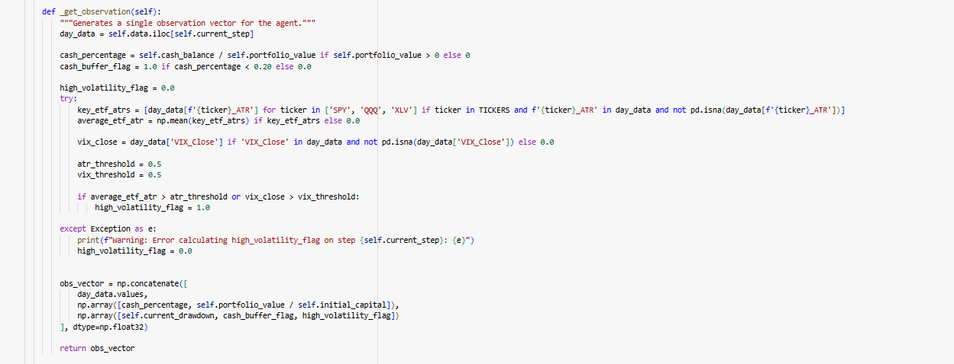
Appendix 7: Action Space
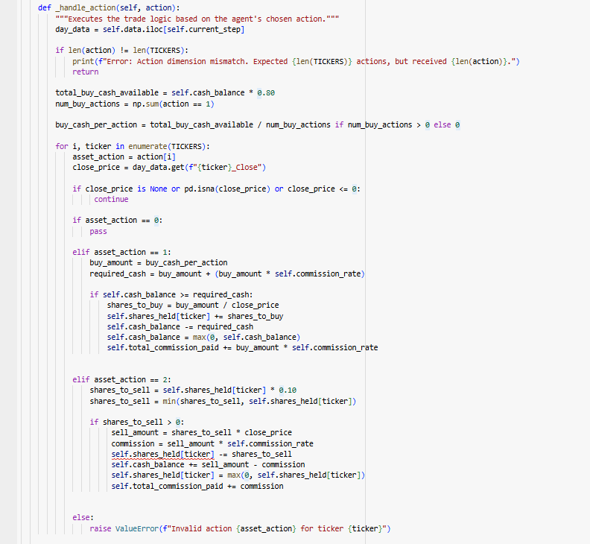

Appendix 8: Reward Function
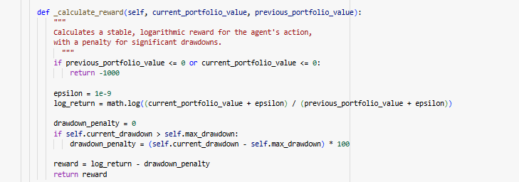

Appendix 9: PPO Agent
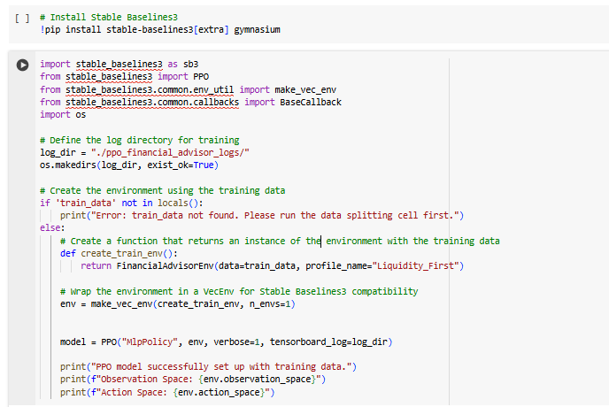
Appendix 10: Model Training & Validation
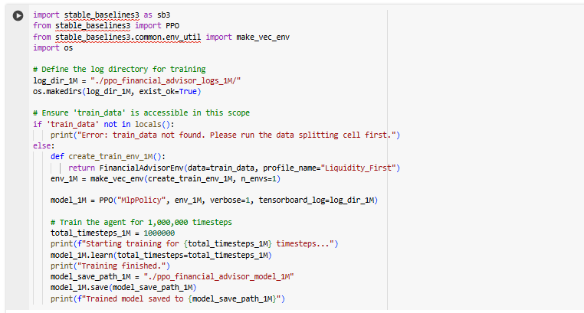
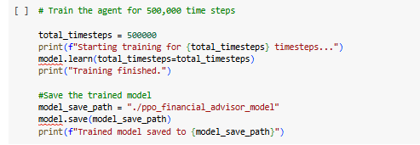
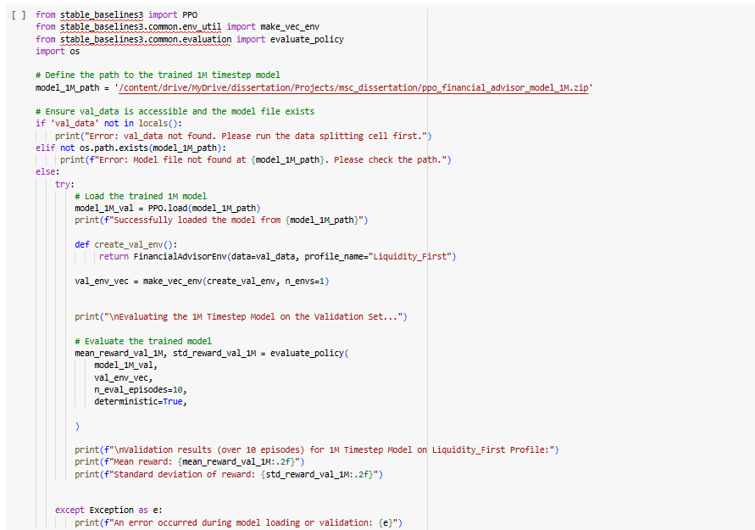
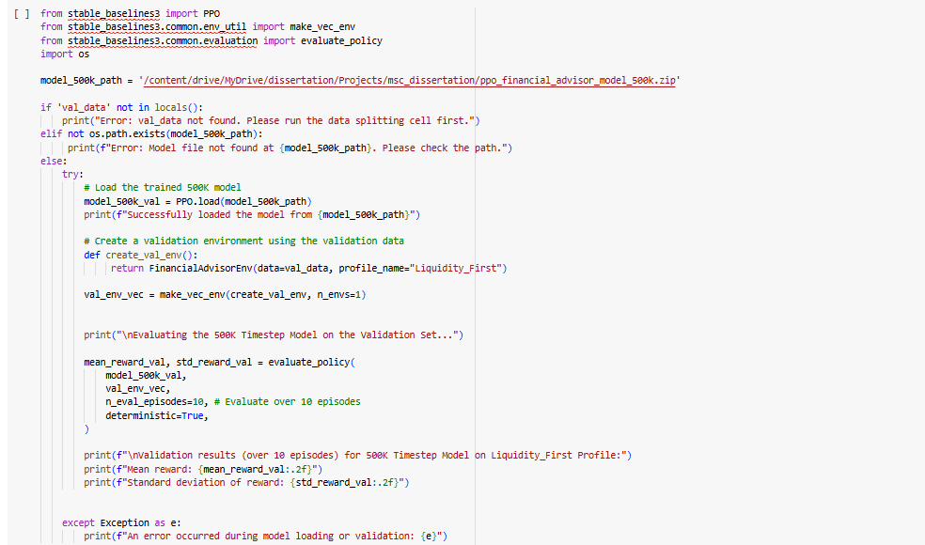

Appendix 11: Custom Evaluation Callback Module
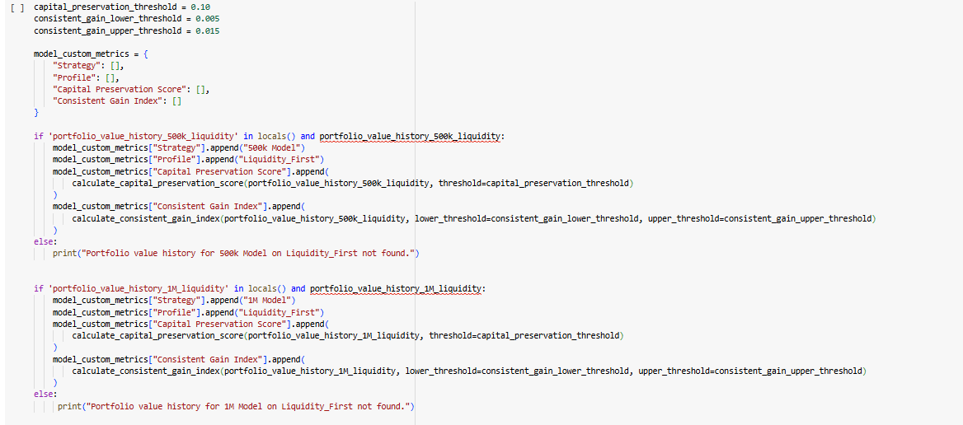
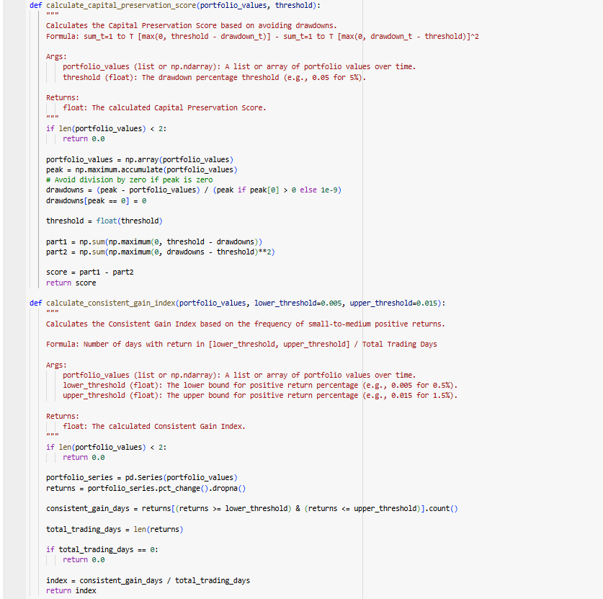

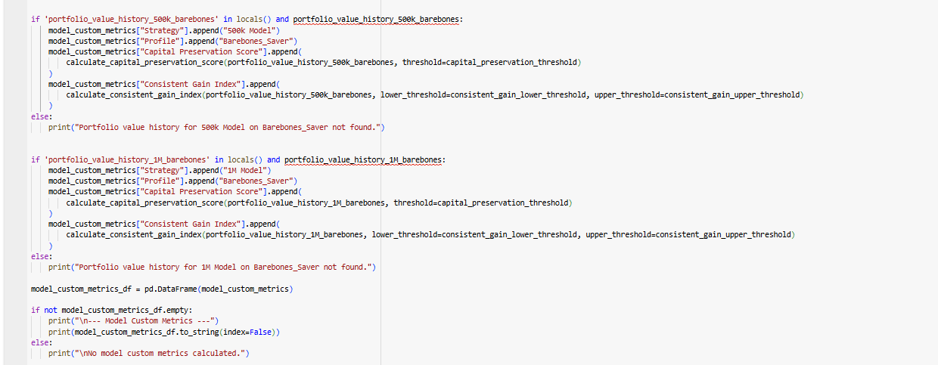

Appendix 12: Buy and Hold Strategy
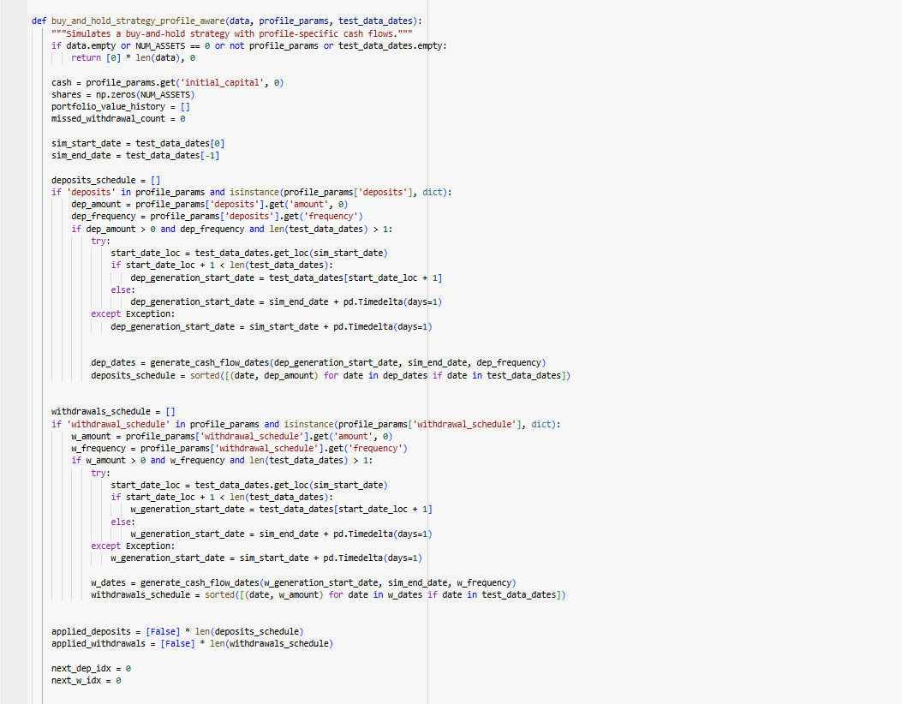
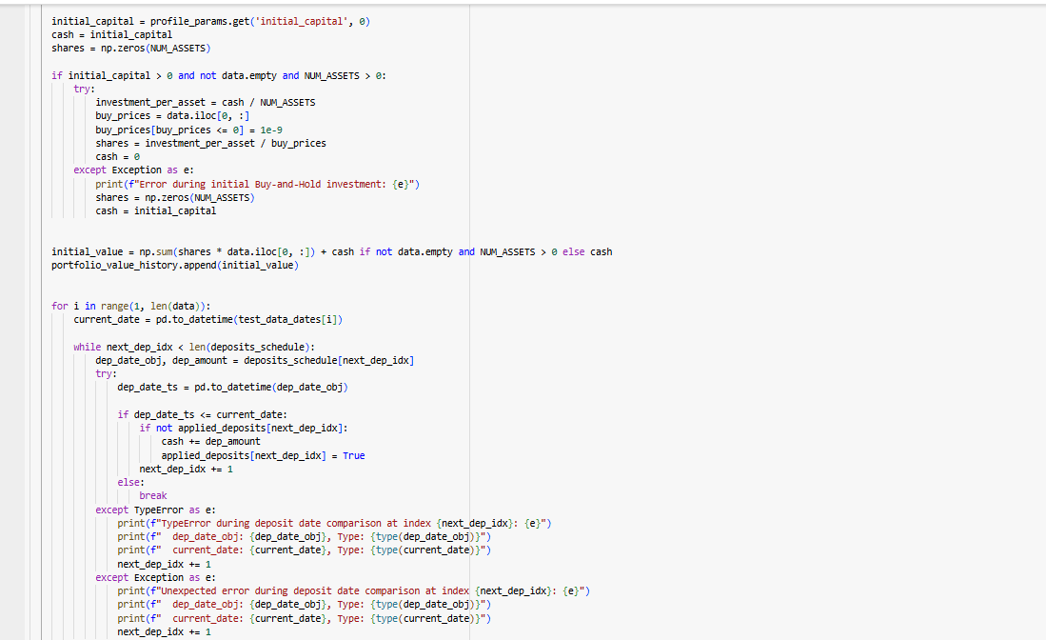
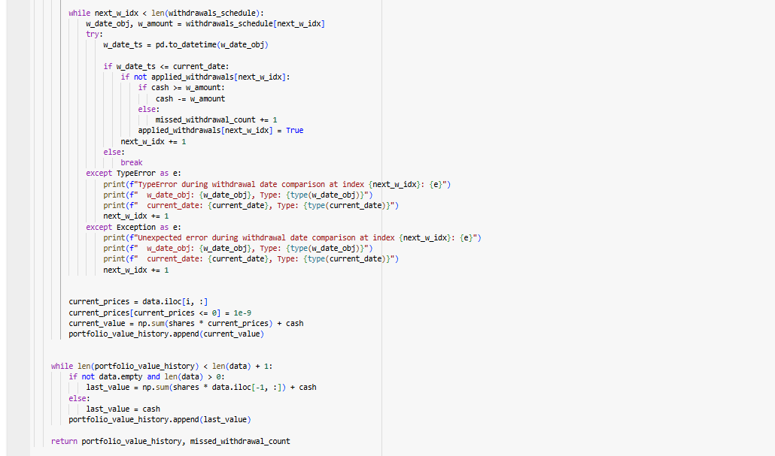

Appendix 13: Equal Weighted Strategy
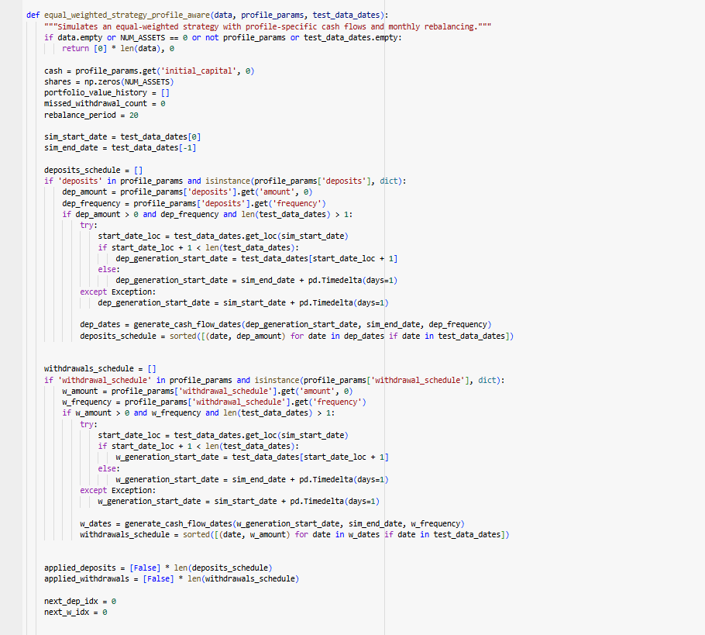
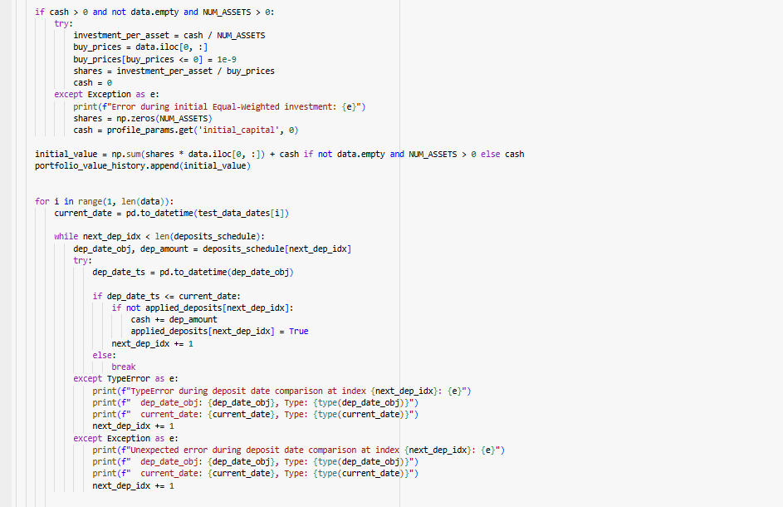
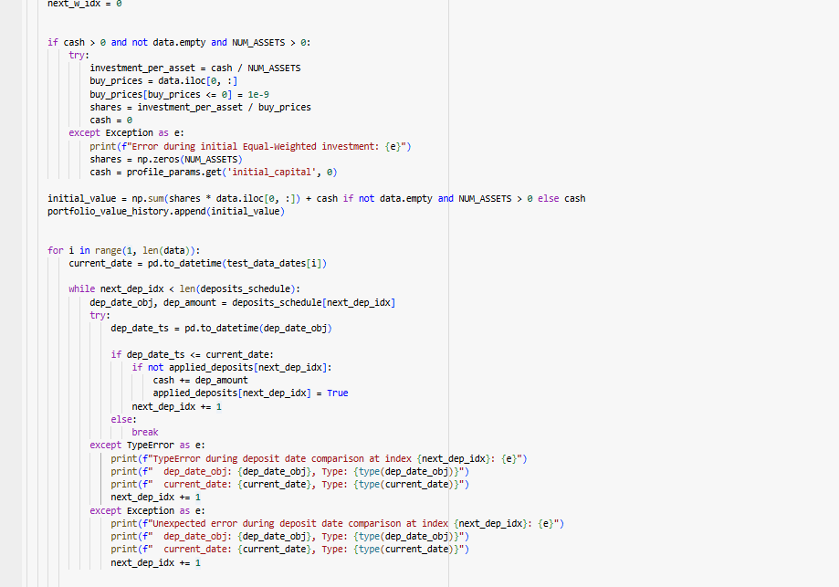
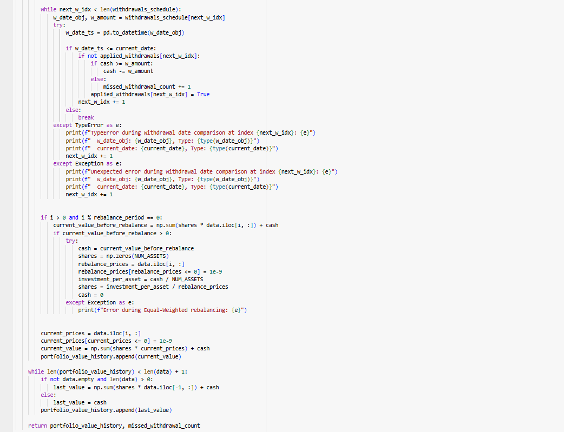

Appendix 14: Rule Based Strategy
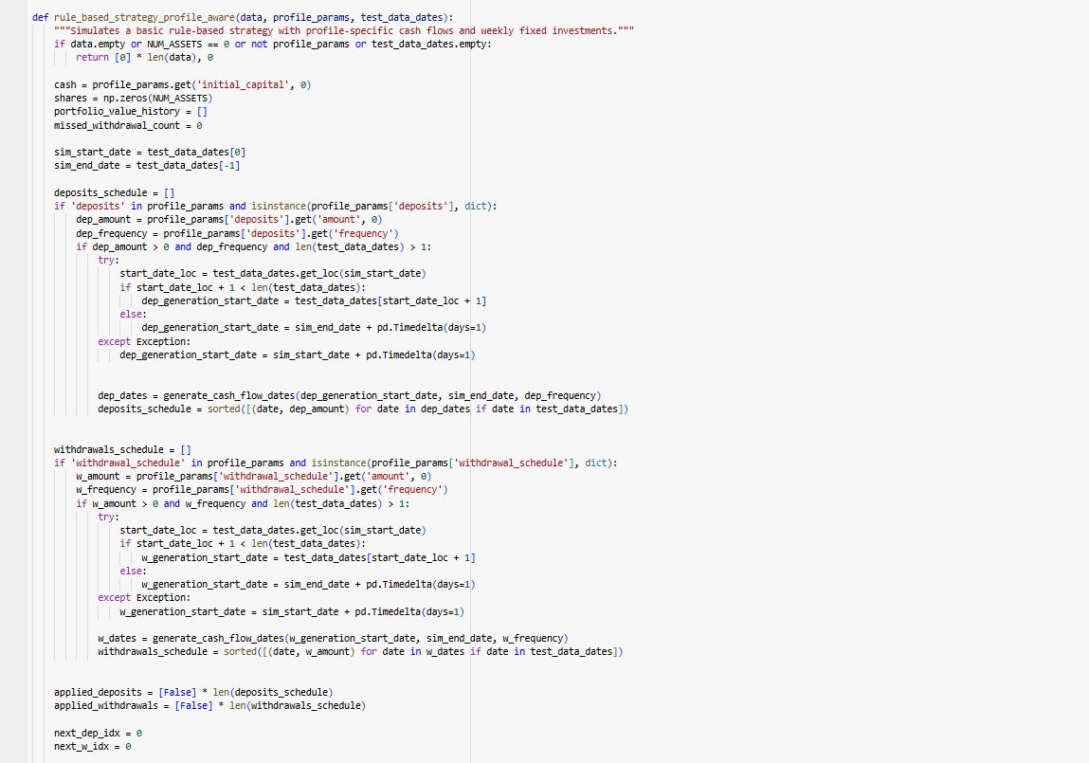
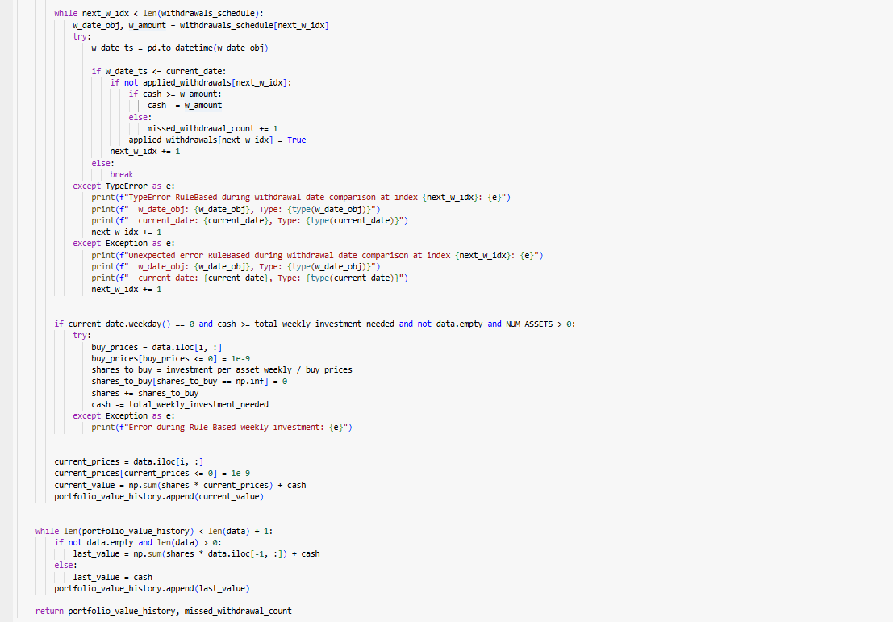
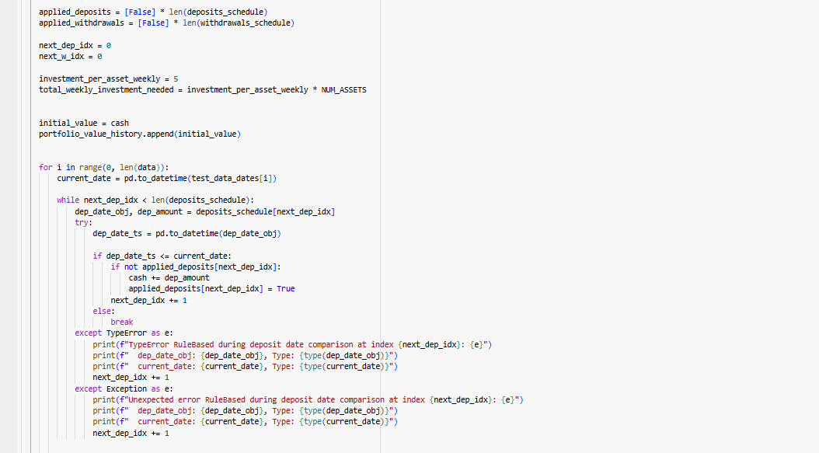

Appendix 15: Models Back testing
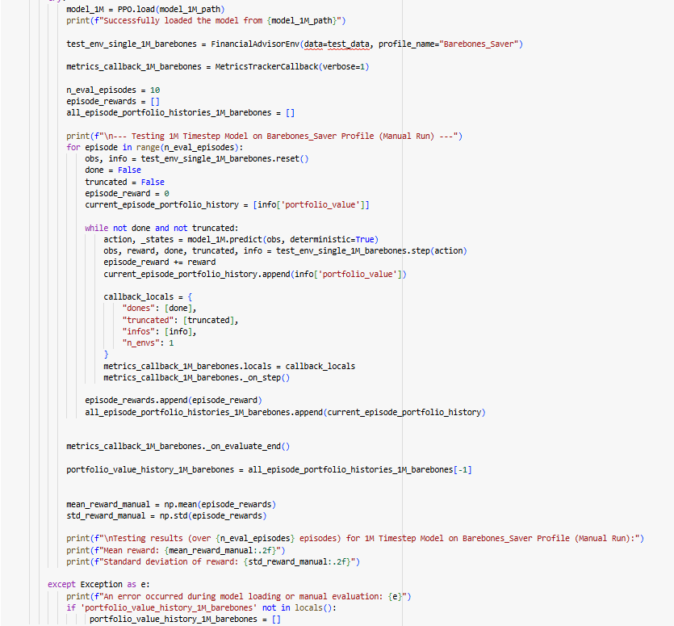
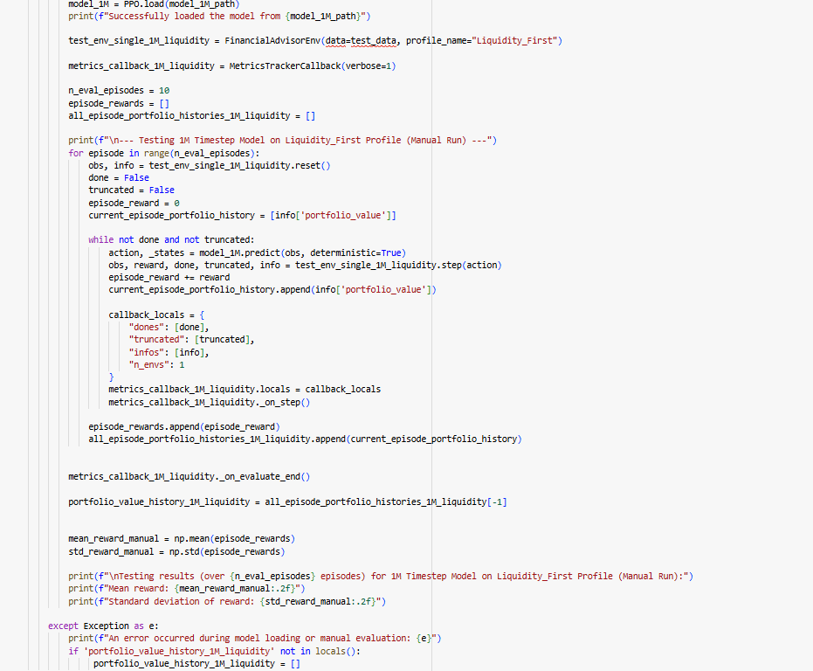

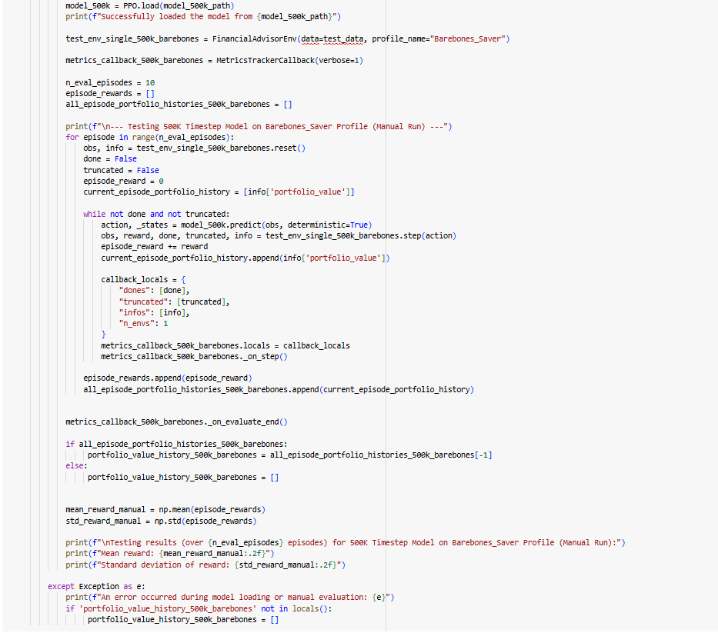
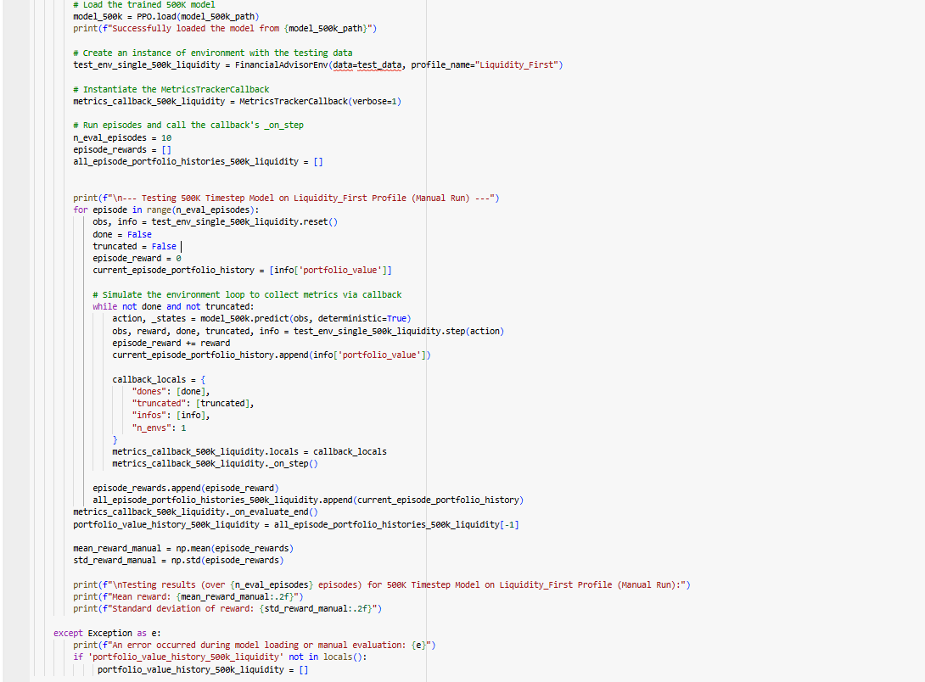

Chapter 8. References
Appel, G. (1979). The Moving Average Convergence-Divergence Method. Great Neck: Technical Analysis of New York.
Bodie, Z., Kane, A. and Marcus, A.J. (2017). Investments. 11th ed. New York: McGraw-Hill Education.
Bollinger, J. (2001). Bollinger on Bollinger Bands. New York: McGraw-Hill.
Cochrane, D.F. (2020). yfinance 0.1.55. [online] Available at: https://pypi.org/project/yfinance/ [Accessed 23 Aug. 2025].
D'Arcy, P. (2019). Behavioural Finance. Place of Publication: Publisher.
Del Amo, L. (2025). Algorithmic Trading Strategies. Place of Publication: Publisher.
Ezinwa, C.I. and Bello, S.A. (2025). 'The Impact of Fintech on Financial Inclusion in Southern Nigeria'. International Journal of Research and Innovation in Social Science, 9(2), pp. 256-273.
Fama, E.F. and French, K.R. (1993). 'Common risk factors in the returns on stocks and bonds'. Journal of Financial Economics, 33(1), pp. 3-56.
The Fawcett Society (2020). Financial Wellbeing in the UK. [online] Available at: https://www.fawcettsociety.org.uk/financial-wellbeing-in-the-uk.
The Fawcett Society and Starling Bank (2020). Money Matters. London: The Fawcett Society.
Fischer, M. (2011). Backtesting. [online] Available at: https://www.investopedia.com/terms/b/backtesting.asp [Accessed 23 Aug. 2025].
Gabhane, R., Gabhane, G. and Meshram, M. (2023). 'A Study on Disposition Effect and Its Impact on Investment Decisions'. Journal of Financial Management, 21(3), pp. 45-60.
Hochreiter, S. and Schmidhuber, J. (1997). 'Long Short-Term Memory'. Neural Computation, 9(8), pp. 1735-1780.
Hussain, M., Muhammad, A. and Butt, M.A. (2019). 'A comprehensive review of data preprocessing methods for neural network-based prediction in various domains'. International Journal of Computer Science and Network Security, 19(5), pp. 165-172.
Jiang, Z. et al. (2017). 'A Deep Reinforcement Learning Framework for the Financial Market'. In: Proceedings of the 2017 IEEE International Conference on Systems, Man, and Cybernetics. Piscataway, NJ: IEEE.
Jönköping University (2025). Investment Strategies for High-Net-Worth Individuals. [online] Available at: https://www.ju.se.
Kola-Oyeneyin, O. and Agidi, C. (2020). 'AI for women’s financial inclusion-analysis of product design and policy approaches in Nigeria'. Research Explorer, XIII(44), pp. 31–?. Available at: https://www.researchgate.net/publication/AI_Women_Inclusion_Nigeria [Accessed 6 Jun. 2025].
Lal, M.S. (2023). Enhancing Investment Decisions with Deep Reinforcement Learning (Combining Multisource Data for Trading Stock). Dissertation (MSc). University of Westminster.
Liang, Z. et al. (2018). Adversarial deep reinforcement learning in portfolio management. arXiv preprint, arXiv:1808.09940. Available at: https://arxiv.org/abs/1808.09940 [Accessed 6 Jun. 2025].
Liu, Y. et al. (2021). 'FinRL: A Deep Reinforcement Learning Library for Automated Trading in Quantitative Finance'. In: NeurIPS 2020: Deep RL Workshop. Available at: https://github.com/AI4Finance-Foundation/FinRL [Accessed 6 Jun. 2025].
Markowitz, H. (1952). 'Portfolio Selection'. The Journal of Finance, 7(1), pp. 77–91.
Mnih, V. et al. (2015). 'Human-level control through deep reinforcement learning'. Nature, 518(7540), pp. 529-533.
Moneybox (2024). Invest your spare change. [online] Available at: https://www.moneyboxapp.com [Accessed 6 Jun. 2025].
Ng, A.Y., Harada, D. and Russell, S. (1999). 'Policy Invariance Under Reward Transformations: Theory and Application to Reward Shaping'. In: Proceedings of the 16th International Conference on Machine Learning.
Newman, K. (2025). Python for AI Development Expertise: Enhancing Real-World Applications with Reinforcement Learning. [online] Available at: https://www.newline.co/@Dipen/python-for-ai-development-expertise-enhancing-real-world-applications-with-reinforcement-learning--000dc085.
OECD (2021). Bridging the Gender Gap in Financial Literacy. [online] Available at: https://www.oecd.org/finance/financial-education/gender-financial-education.htm [Accessed 6 Jun. 2025].
OECD (2021). OECD/INFE 2021 Survey of Adult Financial Literacy. [online] Available at: https://www.oecd.org/financial/education/oecd-infe-2021-survey-of-adult-financial-literacy.htm [Accessed 23 Aug. 2025].
Office for National Statistics (2021). Wealth and assets survey, Great Britain: April 2018 to March 2020. [online] Available at: https://www.ons.gov.uk/peoplepopulationandcommunity/personalandhouseholdfinances/incomeandwealth/bulletins/wealthandassetssurvey/april2018tomarch2020 [Accessed 23 Aug. 2025].
Raffin, A. et al. (2021). 'Stable-Baselines3: Reliable Reinforcement Learning Implementations'. Journal of Machine Learning Research, 22(268). Available at: https://stable-baselines3.readthedocs.io/.
Schulman, J. et al. (2017). Proximal Policy Optimization Algorithms. arXiv preprint arXiv:1707.06347.
Schulze, R. (2020). yfinance: Yahoo! Finance market data downloader. [online] Available at: https://pypi.org/project/yfinance/.
Sharpe, W.F. (1966). 'Mutual Fund Performance'. The Journal of Business, 39(1), pp. 119-138.
Sharpe, W.F. (1994). 'The Sharpe Ratio'. The Journal of Portfolio Management, 21(1), pp. 49-59.
Wang, Z. et al. (2016). 'Dueling Network Architectures for Deep Reinforcement Learning'. In: Proceedings of the 33rd International Conference on Machine Learning, 48, pp. 1995-2003.
Warwick Business School (2018). Are women better investors than men?. [online] Available at: https://www.wbs.ac.uk/news/are-women-better-investors-men [Accessed 6 Jun. 2025].
Whaley, R.E. (2009). 'Derivatives on market volatility: Hedging and speculation with VIX futures'. The Journal of Derivatives, 16(2), pp. 29-45.
Wilder, J.W. (1978). New Concepts in Technical Trading Systems. Greensboro, NC: Trend Research.
WomenTech.net (2025). Fintech for Social Impact. [online] Available at: https://womentech.net.
World Bank (2017). The Global Findex Database 2017. Washington, D.C.: World Bank.
Wu, J. et al. (2019). 'Quantitative Trading on Stock Market Based on Deep Reinforcement Learning'. In: 2019 International Joint Conference on Neural Networks (IJCNN), pp. 1-8.

